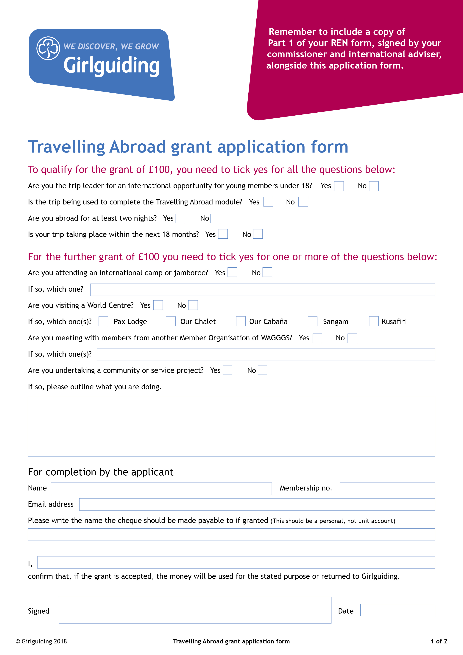

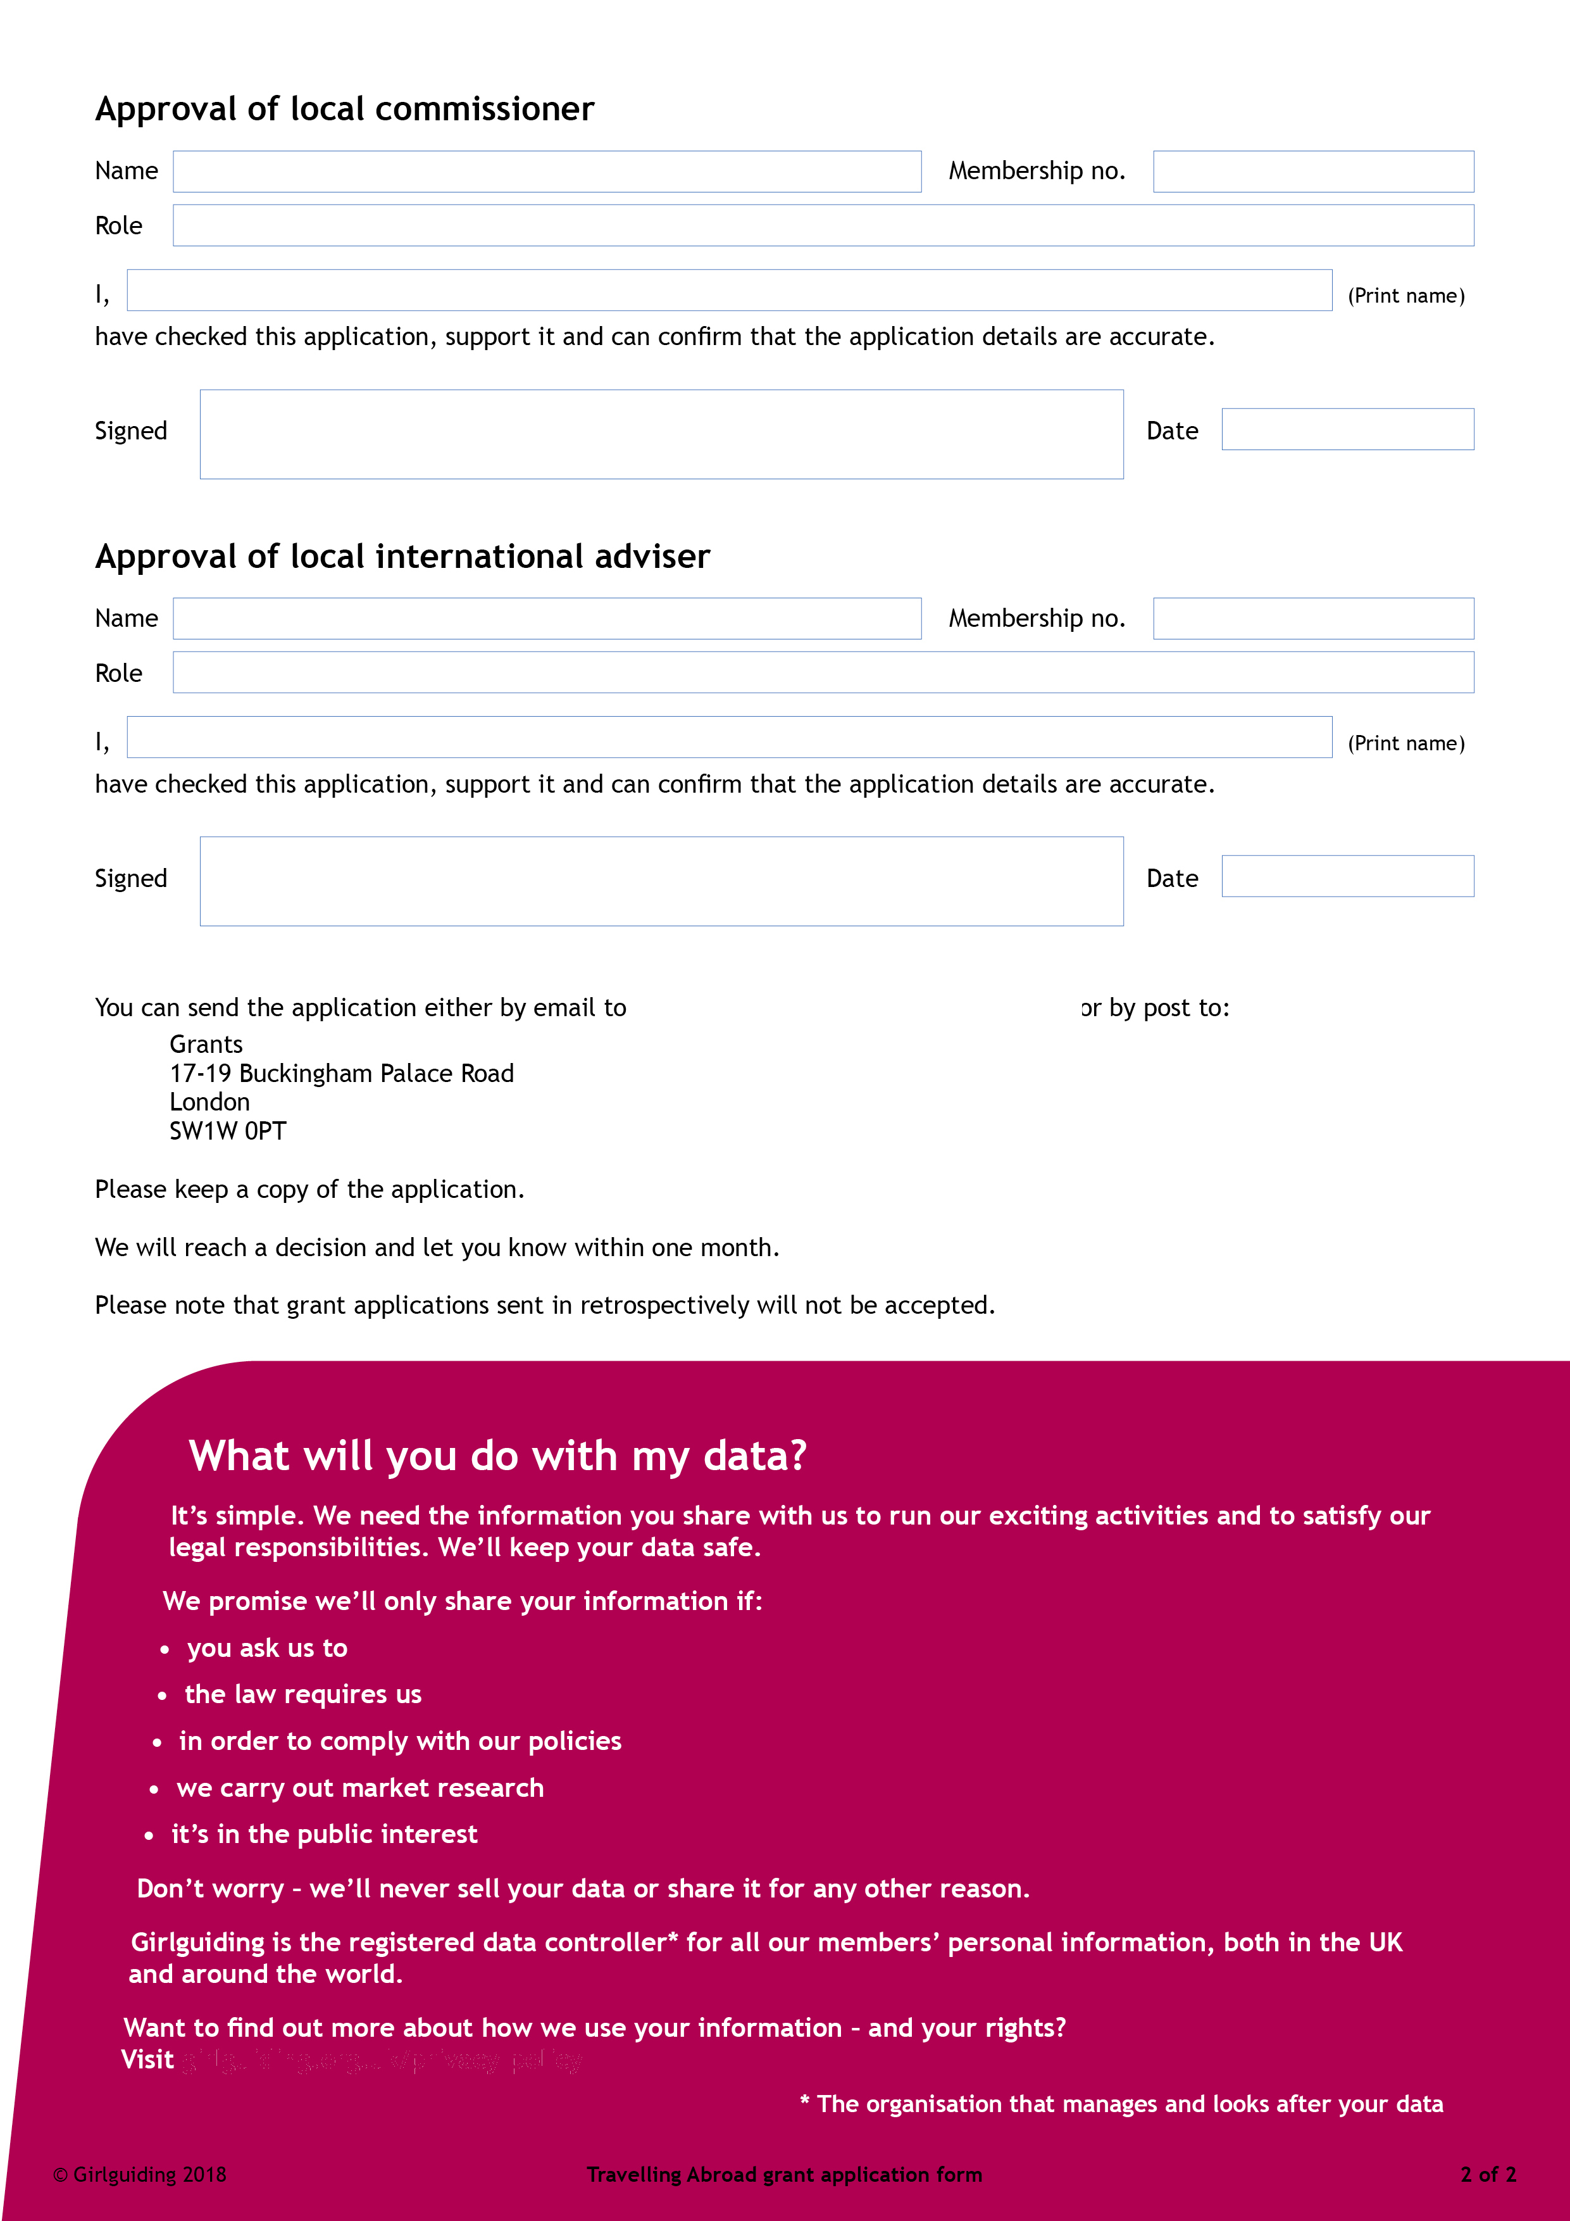

grantsandfunds@girlguiding.org.uk
girlguiding.org.uk/privacy-policy

