Guiding narrowboats
Tuptonia – Owned by Girlguiding Counties of Birmingham and Northamptonshire– moored at Hockley Heath in Warwickshire - http://www.tuptonia.org.uk/
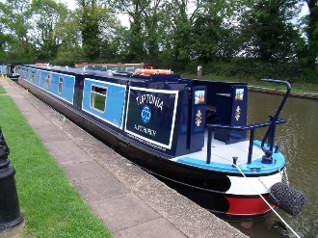

Spirit of Guiding – Owned by Girlguiding West Yorkshire West – Moored at Sowerby Bridge http://www.girlguidingwestyorkshirewest.org/narrowboat

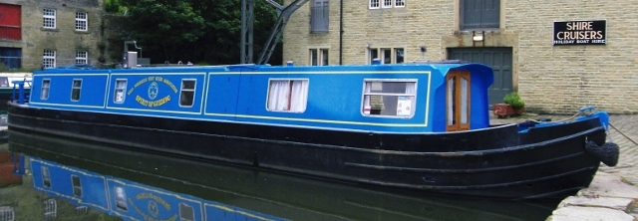

Scouting narrowboats
Ben Gorton – Moored in London - https://scoutnarrowboat.co.uk/

Jubilee Venture & Scout Venture – Owned by Wakefield Scouts – Moored in Wakefield - http://www.jubileeventure.org.uk/

Other community Narrowboats (not exhaustive)
Falcon Adam – Owned by Thames & Kennet Narrow Boat Trust – Moored at Aldermaston, on the Kennet and Avon canal - http://www.narrowboattrust.co.uk/

Centenary – Owned by The Stratford upon Avon Narrowboat Trust – Moored at Hillmorton, near Rugby - http://www.centenarynarrowboat.btck.co.uk/

Dicks Folly & Pickles Folly – Owned by SW Herts narrowboat – Moored at Hunton Bridge, Abbots Langley, Herts.- http://swhertsnarrowboat.org.uk/
Pickles Folly is accessible for one wheelchair user

Angel II – Owned by Community canal boat trust – Moored at Angel, Islington, London - http://www.angelboat.org/

Lancelot & Guinevere – Owned by LNBP – Moored at Braunston, Northamptonshire - http://www.lnbp.co.uk/

Adams Ark – Owed by Doncaster council – Moored at Doncaster - http://www.doncaster.gov.uk/services/schools/adams-ark-canal-boat

Lady Hilda – Owned by KACT – Moored at Great Bedwyn - https://bruce.katrust.org.uk/lady-hilda/

Emsworth & Whistling Swan – Owned by Driftwood Days Boating Co. – Moored at Send, Woking, Surrey - https://driftwooddays.co.uk/

Pices, Spirit, Star & Theo – Owed by Hillingdon narrowboats – On the grand union, moored at Harefield - www.hna.org.uk

Rosanne – Owned by Bromley youth trust – Moored at Leighton Buzzard – www.bromleyyouthtrust.co.uk

Megan & Tinks – Owned by Nottingham narrowboat project - www.meganandtinks.org.uk
Tinks has wheelchair access for 2, non residential
Key summary of boats
Name | Moored | Capacity ª | Length | Skipper available
Tuptonia | Hockey Heath | Sleeps 12 | 70 ft. | Yes
Spirit of Guiding | Sowerby Bridge | Sleeps 10 | 56 ft. | Yes, enquire when booking
Ben Gorton | Northolt, London | Sleeps 12 + 2 helms, Ideal for 8 participants | 70 ft. | Included in hire
Jubilee Venture | Wakefield | Sleeps 10 | 47 ft. | Enquire before booking
Scout Venture | Wakefield | Sleeps 10 | 52 ft. | Enquire before booking
Falcon Adam | Aldermaston Wharf, Padworth | Sleeps 12 | 70 ft. | Yes enquire when booking
Centenary | Hillmorton, Rugby | Sleeps 12 | 70 ft. | Enquire before booking
Dicks Folly | Hunton Bridge, Abbots Langley, Herts. | Sleeps 12 | 70 ft. | Enquire before booking
Pickles Folly^{b} | Hunton Bridge, Abbots Langley, Herts. | Sleeps 10 | 60 ft. | Enquire before booking
Angel II | Angel, Islington, London | Sleeps 12 | 72 ft. | Yes
Lancelot | Braunston, Northamptonshire | Sleeps 12 | 70 ft. | Yes
Guinevere | Braunston, Northamptonshire | Sleeps 12 | 60 ft. | Yes
Adams Ark | Doncaster | Sleeps 11 | 52 ft. | Yes
Lady Hilda | Great Bedwyn | Sleeps 9 | 62 ft. | Yes
Emsworth | Send, Woking Surrey | Sleeps 8 |  | Enquire before booking
Whistling Swan | Send, Woking Surrey | Sleeps 12 | 70 ft | Enquire before booking
Pisces | Harefield, Uxbridge | Sleeps 11 |  | Yes with charge
Merlin | Harefield, Uxbridge | Sleeps 11 |  | Yes with charge
Theo | Harefield, Uxbridge | Sleeps 12 |  | Yes with charge
Star | Harefield, Uxbridge | Sleeps 12 |  | Yes with charge
Rosanne | Leighton Buzzard | Sleeps 13 |  | Yes with charge
Megan | In city centre nottingham | Sleeps 10 | 70 ft | Included in charge
Tinks  Wheelchair access for 2 | In city centre nottingham | Sleeps 10 | 70ft | Included in charge
ª Capacity includes adults and skipper/helm, ideal number of participants considers sleep arrangements for splitting under and over 18’s
^{b} Can accommodate a wheelchair user. A hydraulic lift takes people with mobility difficulties between the larger 'cruiser' rear deck and the cabin

