Leaders’ guidance
Ready, set, lead
2 July 2025

Contents
1 What is ready, set, lead and how does it work? 2
1.1 What is ready, set, lead? 2
1.2 The 5 leadership areas 2
1.3 Get ready 3
1.4 Get set – Guide leadership challenges 3
1.5 Lead – leadership in action tasks 3
1.6 Choosing what to do 4
2 Supporting Guides doing ready, set, lead 4
2.1 Who can do ready, set, lead? 4
2.2 Helping Guides explore ‘leadership’ 4
2.3 Supporting ‘get ready’ 5
2.4 Supporting ‘get set – Guide leadership challenge’ 6
2.5 Supporting ‘lead! – leadership in action’ 6
2.6 Supporting as a Rainbow or Brownie leader 7
2.7 Adapting the activities for your Guides 7
2.8 Celebrate & badges 7
2.9 Recording ready, set, lead on GO 7
2.10 Timeline for supporting Guides with ready, set, lead 9
3 Frequently asked questions (FAQs) 9
3.1 How long will it take for a Guide to complete ready, set, lead? 9
3.2 Does ready, set, lead count towards the Guide programme awards? 10
3.3 What can a Guide do when she has completed ready, set, lead? 11
3.4 How does ready, set, lead link to the young leader development programme (YLDP)? 11
4 Appendix 1: Guide leadership challenge (activity by activity) 12

If you would like to share any feedback or thoughts with the young volunteer team or ask any questions, please do email programme@girlguiding.org.uk

What is ready, set, lead and how does it work?

What is ready, set, lead?
Ready, set, lead is a resource for Guides to help them grow their confidence and leadership skills. It has been developed by Guides, for Guides.
It is optional and flexible, designed to work around the core programme offer for Guides.
Ready, set, lead has 3 parts:
- Get ready – warm up activities designed to encourage self-leadership and introduce the resource.
- Get set – the Guide leadership challenge. Games, scenarios and immersive experiences, all designed to help a Guide explore leadership.
- Lead – Guide leadership in action. A set of tasks which help the Guides put leadership into action practically in their unit(s).
Guides start with the get ready section and then choose whether to complete 1 or 2 of the other parts.

The 5 leadership areas
These areas are here to help Guides explore different behaviours and characteristics of leadership.
 | The leader I want to be  Explore how they can be the leader they want to be for themselves and others by exploring the skills and behaviours of good leaders. These include listening, empathy and self-awareness, all of which create a foundation on which they can build their other leadership skills.
 | Keeping safe  Linked to our creating safe spaces together resource, this section encourages them to do some of those activities and think about how safety can be applied in your unit space when planning and running activities.
 | Making a difference  Explore how to make things a little better – in their unit, in the world or about something they’re passionate about.
 | Planning activities  This helps with the nuts and bolts of how to run a fun, inclusive unit. Explore how to make great plans, get involved at planning meetings and/or solve problems as they arise.
 | Running activities  Put facilitation into action and practising running activities for other people – whether that’s a small group or their whole unit.

Get ready
These are short activities, similar to the welcome leaflet for the young leader development programme. It sets the scene for leadership and helps them set goals, find out how their unit works and begin to explore their own leadership style. This sets them up with self-leadership.
Once they have finished this section, they can decide what to do next – build their confidence with get set or put the skills straight into action with the lead section.

Get set – Guide leadership challenges
This section is filled with games and activities designed to upskill Guides in the 5 leadership areas. They can be completed individually or by Guides working together in small groups.
There are a variety of activities in each area, allowing Guides to pick and choose which ones suit their needs. These activities can be done in your unit meetings or alongside other programme activities.
When a Guide completes 4 activities from the leader I want to be area, and 2 activities from each of the other areas, they’ll have achieved the Guide leadership challenge badge.

Lead – leadership in action tasks
This is where individual Guides put their leadership skills into practise in their unit. There are suggested tasks for each leadership area to choose from.
Guides should complete 15 tasks in total, at least 2 from each leadership area. The rest can be chosen from any leadership area, or they can add up to 5 tasks of their own.
When a Guide has completed 15 tasks, they will have achieved the Guide leadership in action badge.

Choosing what to do
Guides don’t have to do both parts of the resource. If they are already confident about their leadership skills, they can go straight into the leadership in action tasks. If they would like more support and to build their confidence and leadership skills, we recommend they do the leadership challenges first. Then they may choose to complete the leadership in action tasks at a later date.

Supporting Guides doing ready, set, lead

Who can do ready, set, lead?
Ready, set, lead is for all Guides who want to develop their leadership skills. This might be because they have, or would like to have, a leadership role within the Guide unit such as patrol leader or patrol second or a volunteer role in another unit such as Rainbow or Brownie helper.
Guides you might wish to show ready, set, lead to include:
- Those in leadership roles.
- Those older Guides who need another challenge.
- Those who would like a focus beyond the activities you’re doing in your unit.
- Those who wish to go on to become a young leader.
- Those who wish to do the Guide camp permit, who you feel would benefit from developing their leadership skills further first.
- Those who show leadership qualities already, including speaking up for others, taking charge when needed, helping others, reacting well when things don’t go to plan and showing empathy.
- Any who shows interest or who would benefit from growing their leadership skills!
Ready, set, lead can help them take the lead in their units or own lives and can help them grow their confidence in becoming the leader they want to be.

Helping Guides explore ‘leadership’
In Girlguiding, we often associate leadership with a series of practical roles within the unit setting (formal leadership). But outside of guiding, leadership is a phrase used in different settings – school, work, sport, politics and many more. There is no single definition of being a leader – it takes all sorts of skills to be a leader in life.
In ready, set, lead we focus on the behaviours and skills that leaders demonstrate as well as how to practically do leadership in a unit, so Guides can learn skills they transfer into their life outside. These skills can be part of self-leadership (defined in the resource) and informal leadership (taking the lead without a role).
There are some key concepts about leadership which can help your Guide explore the idea of leadership:
 Leadership needs to be practised – just like you practise anything you want to get better at. It can be practised whatever your age and role.
Leaders are constantly learning and it’s important to share when you don’t know something and find extra information to be better leaders.
Guides promise to do their best, but everyone gets it wrong sometimes and makes mistakes. Good leaders are kind to themselves when we make mistakes.
Leaders need to change how we lead to suit the situation we are in and people around us.
Sometimes women and girls in leadership are called ‘bossy’ or other unkind words – but there is no one way to be a leader. We should celebrate leaders and challenge stereotypes about leadership.
If you want to grow your leadership skills, check out the leadership development programme or take a look at the world association of girl guides and girl scouts leadership model.

Supporting ‘get ready’
This is a Guide’s start to her ready, set, lead journey and is a great time to sit down with them and talk through the resource together.
You can help Guides by:
- Encouraging them to set goals which are a stretch for them and their skills – whether that’s completing part of the resource, a few activities or both badges. Help them to set goals which encourage them to build particular leadership skills.
- Gently nudging them to find information out for themselves in the treasure hunt.
- Keeping them moving - this section shouldn’t take more than a few weeks to complete, so do encourage them to keep moving and when they’ve finished ask them to decide which elements they want to do moving forward.

Supporting ‘get set – Guide leadership challenge’
This section is about choosing activities which work for your unit and your Guide(s). There is a choice of activities giving flexibility, so you can choose what works for your Guides and in your unit. In appendix 1 there is a table which goes through all of the activities in one place to help you think about how to plan them into your programme.

Supporting ‘lead! – leadership in action’
This section is about choosing the right tasks for your Guide and helping them to complete these in the unit meeting. They will need time and space to choose these, and then do them! Most of the tasks should be things it’s easy for them to jump into around your regular unit meetings.
Guides can choose from a suggested list of tasks to show their leadership skills in each area, they can also add their own tasks if there are other things they can do in their unit to reflect the leadership skill.

Creating tasks
When creating tasks from scratch, make sure you’re helping to create something that is:
- Specific – it gives them a discreet thing to do and tick off.
- Achievable – it is something you can reasonably ask a Guide to do with the resources they have available and their own skills.
- Challenging – it sets a level of challenge that is appropriate for that Guide.
- Linked to a specific leadership area – it needs to meet the outcomes or skills outlined in one of the leadership area.
- Timed and timely – it won’t take more than a couple of weeks to complete (most should be done within one meeting) and is linked to something that’s happening soon.
If you get stuck creating tasks, do use the ones in the main list – there should be some that work for your unit.

Determining if a Guide has completed a task
Guides should tell their leader which tasks they would like to complete, and then you can see when they do it. You know your Guides and what they are capable of, so the tasks can be adapted if required. Sometimes things might not go to plan, but that doesn’t always mean that the task hasn’t been completed – Guides can still grow and develop from this and see what they could do differently in future.
If you, having seen your Guide do the task, believe she has done it, great! If she has someone else to vouch for her, great! If you have any evidence, great! Ultimately, getting the experience is what matters here. You can sign the planning sheet to show that a Guide has done the task.

Supporting as a Rainbow or Brownie leader
You may be accessing this support for a Rainbow or Brownie helper. You can support in the same way as a Guide leader, signing off tasks which have been completed on the planners and helping the Guides to complete them in your unit. You won’t be able to add the badges onto GO, which means you will need good communication with the Guide leader.
You may wish to watch our video about working with Guides to reflect on how they are different from the girls in your unit.

Adapting the activities for your Guides
You know your Guides and what will work for them or won’t! We have some specific guidance online which can help with adapting resources for Guides with different, specific needs.
If you have a specific support need, or a version of the resource you need in an alternative format, please email programme@girlguiding.org.uk and we will do what we can to help.

Celebrate & badges
Badge ceremonies, horseshoes, district or division presentations, county days – celebrate the Guides who have completed either of their badges (and don’t forget to get them the badge!).
You can buy the badges from the online Girlguiding shop, or wherever you usually get your badges from.
Guide leadership challenge badge: https://www.girlguidingshop.co.uk/product/1246
Guide leadership in action badge: https://www.girlguidingshop.co.uk/product/1247

Recording ready, set, lead on GO
Guide leaders can record the completion of the Guide leadership challenge badge and/or the leadership in action badge on GO. You’ll find these badges under the ‘Other badges’ tab in the programme recording area, in the same place as the eco-award. Here is the popup which will appear when you select the ‘other badge’ function:
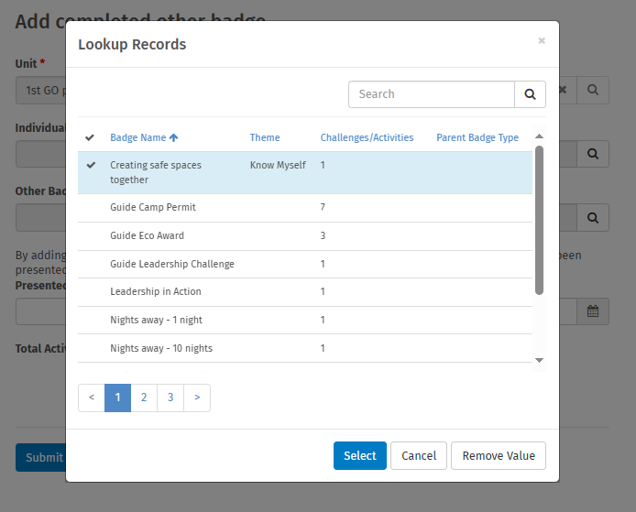
You can use this to search for the Guide leadership challenge and leadership in action. We are only recording these badges when they are done, to minimise administration.
If you would like the ability to add each individual activity, please do email programme@girlguiding.org.uk with this feedback.

Timeline for supporting Guides with ready, set, lead
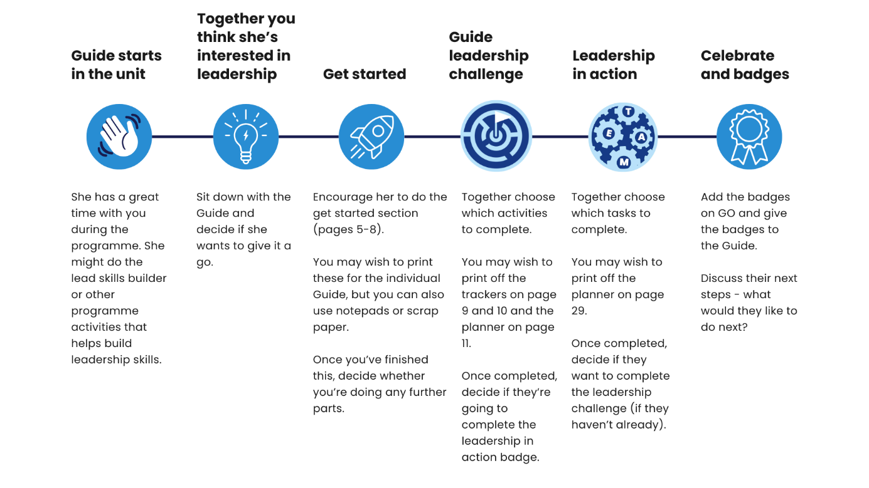

Frequently asked questions (FAQs)

How long will it take for a Guide to complete ready, set, lead?
That really depends on the individual Guide, what they would like to do, and how they can fit the challenges and tasks around the rest of the activities you are doing in your unit meetings.

Leadership is a journey and the skills to be a good leader need to be developed and practised over time, so this resource is not something that can be completed in one night. Instead, we would recommend allowing at least a term to complete the leadership challenges within your unit meetings, and a further term for Guides to put into practice what they have learnt and complete the leadership in action tasks.

Does ready, set, lead count towards the Guide programme awards?
Ready, set, lead is an additional standalone resource which is separate to the Guide programme. It’s designed to be a Guide’s own journey, to be done in groups or by themselves; flexibly, at a speed (and timings) that work for them; within their patrol or helper roles. Therefore, as a whole resource it doesn’t count towards the Guide programme awards.
That said, there are a lot of opportunities for Guides to gain UMA minutes while doing the resource in their Guide unit, through these activities:
Section | Activity | How to achieve UMA minutes
The leader I want to be – lead! / leadership in action | Help create some patrol or unit guidelines | Use games maker UMA for Guides
The leader I want to be – lead! / leadership in action | Ask for feedback after running an  activity and act on it | If you run a UMA in Guides,
The leader I want to be – lead! / leadership in action | Spread kindness | Do the power of positivity Guide UMA
Keeping safe – get set / leadership challenge | Risky business | Choose any Guide UMA for this activity and run it after you have risk assessed together.
Keeping safe – lead! / leadership in action | Run a wellbeing activity | Choose a Guide wellbeing UMA
Make a difference – get set / leadership challenge | Check my feelings | Run checking in (be well UMA)
Make a difference – lead! / leadership in action | Explain the promise to someone new | Use one of our Guide promise UMAs to do this activity.
Planning activity – get set / leadership challenge | Adaption is key | Adapt a Guide UMA then run it.
Planning activities – lead! / leadership in action | Organise and prepare the resources for an activity  Or any of the other prepping for activities ones | Plan to run a Guide UMA
Running activities – get set / leadership challenge | Master of instruction | Use the instruction disruption UMA to achieve the same goal as this activity.
Many of the leadership in action tasks in the running activities area can be used to complete UMA hours.
If there are particular UMAs or skills builder activities that a Guide needs to complete to achieve a section award, why not encourage her to run these activities for her patrol, a small group or even the whole Guide unit – then she’ll be completing her leadership in action tasks at the same time!

What can a Guide do when she has completed ready, set, lead?
If your Guides have enjoyed completing ready, set, lead, they might be interested in taking their leadership skills further by taking on a new role or trying out a new challenge such as the Guide camp permit or the Guide eco award.

Once they finish Guides, they might want to become a young leader or peer educator, discovering and exploring their leadership skills further and empowering others.

How does ready, set, lead link to the young leader development programme (YLDP)?
Ready, set, lead is similar to the young leader development programme in that there is a ‘learning section’ (discovery resources and Guide leadership challenge) and ways to put this into action (tasks and leadership in action).
Guides who have completed ready, set, lead may be ready to jump into the tasks for:
- Delivering activities
- Giving girls a voice
- Keeping it kind
- Planning your activities
- Running activities safely
- Supporting inclusive spaces
Although the discovery resources are available for them.
Some tasks in ready, set, lead are similar to those in the young leader development programme. These are tasks that should be regular parts of their roles in guiding. Repeating these in the YLDP will reinforce this knowledge and help them develop their skills further.

Appendix 1: Guide leadership challenge (activity by activity)
Remember, Guides can choose which challenge activities they want to complete from each leadership area. All the activities are listed below to help you support your Guides to complete the ones they choose.
Leadership area | Activity | Notes
The leader I want to be | Skill Scenarios | Guides could do this in groups or individually, they might need some support to realise that there are different ways to be a leader, and all these skills are useful.
The leader I want to be | I’m the leader it’s me | This works best in a small group and is a chance for Guides to think about all the different leadership skills – some which might not be as obvious. Guides might like to think about which skills they would like to improve as they go through the resource
The leader I want to be | Praise giver | Guides can complete this on their own or as a group if a few Guides are working on the resource. They should look out for the positive things that others in the unit do or say and note this down to practice giving positive feedback to others. A leader should double check what feedback is being given to others in the unit.
The leader I want to be | Not the end of the world | This activity helps Guides to build their resilience when things don’t go to plan. As a leader you can help to offer support to overcome mistakes.
The leader I want to be | Unawesome leader | Guides can complete this activity on their own on in a group. They should keep their words light-hearted and avoid focusing on any particular person. Make sure they also spend time on the flipside of what makes an awesome leader.
The leader I want to be | Role models | Works best in a Guide unit as it’s easier to do in a group of peers – Rainbow and Brownie helpers should do this where they are Guides.
Keeping safe | Safety Map | This is for individual Guides to be better aware of how to keep people safe in their meeting place. As a leader you make need to show them some of the different safety precautions you do in your unit.
Keeping safe | Wellbeing Kit | This is for an individual Guide to create their own wellbeing kit, to make sure they know how to look after themselves. They don’t necessarily have to share this with anyone, but make sure Guides know they can talk to a leader if they need help or to take a break. This activity is from the 10-13 A safe space activity sheet.
Keeping safe | Risky Business | Guides can work individually or in small groups to identify hazards, risks and solutions for an activity. It might be useful to help them choose an activity which has quite a few obvious risks (e.g fire, cooking, tools, online safety, or out and about) This activity is from the 10-13 A safe space activity sheet.
Keeping safe | Safety Tips | Guides can work individually or together to come up with some safety tips for their unit and a creative way to share them with the rest of their patrol or unit.
Making a difference | Newbie | This is for an individual Guide to imagine being a new member of the unit again. They should let you know before the meeting that they plan to do this activity, and then can do it in the next meeting. They may have ideas after the meeting that they want to suggest to make meetings more welcoming to new people.
Making a difference | Check my feelings | An important part of being a good leader is being able to check on how others are feeling and support them if needed. Guides can use some of the suggestions in the resource to do this with their patrol, or another small group. Rainbow or Brownie helpers could do this with a small group of Rainbows or Brownies.  If a Guide wants to run a programme activity to complete this activity they can tick off running a well-being activity from the leadership in action tasks.  Make sure that Guides know they can talk to a leader if any of their friends or other members of the unit says anything that worries them.
Making a difference | Passion Projects | This is an opportunity for individual Guides to share something which is important to them with others in their unit. They can do this in anyway they like, but should check their plans with a leader first. The topic can be big – like climate change or mental health, or it could be something smaller like a sport they are good at, or a craft they want to share with others, or even a bit silly like their views on the best biscuits!
Making a difference | Unique Everyone | This activity focuses on inclusion and making a welcoming and accessible space for everyone. As a leader you may need to tell the Guides about things you already do, and they can suggest anything further they think could be done.
Planning Activities | Snowball fight | This activity is one way to get girls in your unit to suggest ideas for things they would like to do. Guides can then use these ideas to help plan activities
Planning Activities | Planning meeting bingo | This activity can be completed by a Rainbow or Brownie helper attending a leadership planning meeting at the unit they help with or Guides attending a patrol leaders council or other opportunity they may have to attend a planning meeting. If the words on the grid are not applicable for your unit, you can add new ones.
Planning Activities | Advice letter | This activity is to help Guides when things don’t go to plan. Guides could write a reply to the scenarios, chat it through with a leader or their patrol or act it out in a group. This can be completed individually or in a group. There’s no right or wrong answer so help them to choose the best response.
Planning Activities | Adaption is key | This is to help Guides think about how to adapt a planned activity so it works for their group or unit. They can complete this as a group or individually.
Running activities | Leader lookout | This is a chance for individual Guides to observe the other leaders in their unit, and how they deliver activities. This helps them to work out how to run different activities. Let the Guides know why you ran the activity as you did, and if there’s anything you’d do differently in future.
Running activities | Master of Instruction | This activity works best with other Guides rather than with Rainbows or Brownies. It’s a chance for Guides to really think about the instructions they give. The other Guides need to follow these exactly, so if they are not clear, they might not do what is expected.
Running activities | Tricky behaviour | Sometimes behaviour can be tricky when Guides are running activities. This activity can be completed individually or as a group, and helps Guides to think about how they can manage behaviour in different situations. Make sure the Guides know when leaders can step in and help instead.
Running activities | It’s listening time | This is an opportunity for Guides to get feedback on a game or activity they have run. If they don’t want to run the activity themselves, they could use the suggestions to gather feedback from a small group about another activity they have completed and share that with the leadership team

