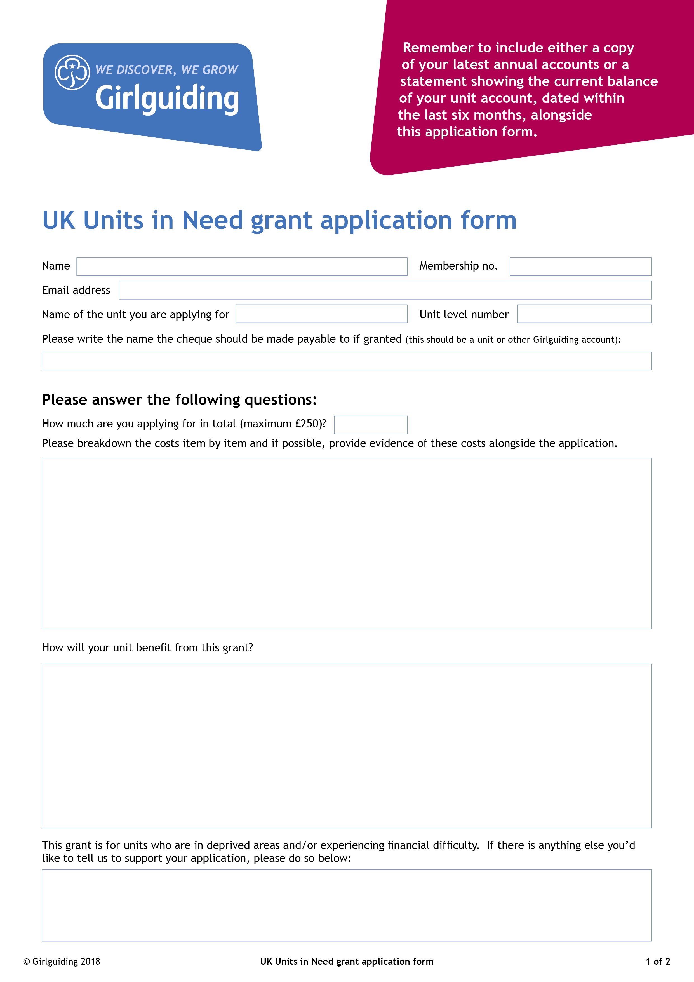

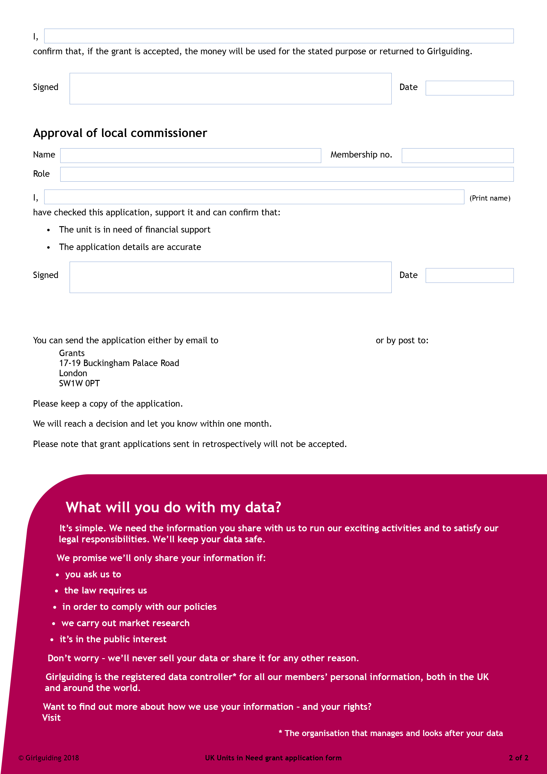
privacy-policy
grantsandfunds@girlguiding.org.uk

girlguiding.org.uk/privacy-policy

