Please fill in the relevant sections of this form and return to Trading Service

Personalised county commissioner
thank you badge form
We all love badges, and it’s nice to say thank you. So to help you say thank you from your county commissioners we’ve created a badge you can personalise with your county name. This badge is woven and 70mm in diameter.
To order your badges simply complete this form and return to Trading Service using the contact details provided. Once confirmation and payment have been received orders take approximately 4-5 weeks for delivery.
Your details
Name
Membership number
Unit/district/division/county
Your Trading Service account number (volunteer shop or private)
If you don’t have one, please leave blank.
Invoice address (including postcode)
Delivery address (if different to invoice address)
Daytime telephone number
Email address

Costs
The cost of your personalised badges varies based on the number you order. The table below sets out the unit price for different order quantities. There’s a minimum order quantity of 100 badges.
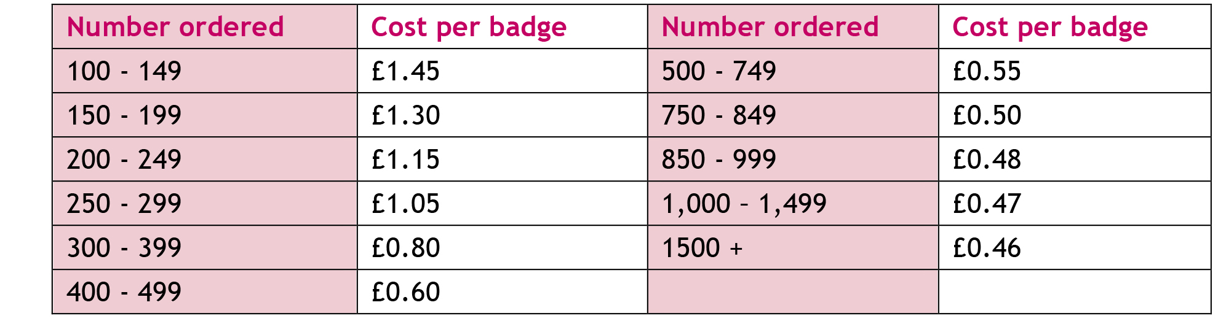

Your order
C1  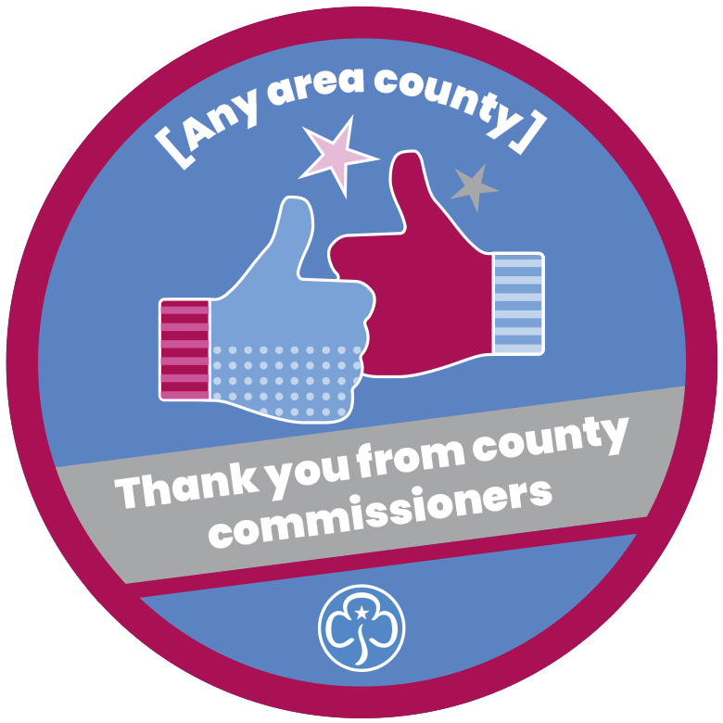 | Quantity
Date required (dd/mm/yyyy)
We’ll aim to deliver by this date, but cannot guarantee it.
 | Personalisation – county name

Please note, once confirmation has been received you cannot cancel or return orders made to your specification unless they are faulty.
To read our full delivery and returns information please go to girlguidingshop.co.uk.
For all return enquiries, email us at bespoke@girlguiding.org.uk or give us a ring
on 0161 941 2237.

Signed
We accept electronic signatures.
Date (dd/mm/yyyy)

Once completed please return this form by email to bespoke@girlguiding.org.uk.

