Please fill in the relevant sections of
this form and return to Trading Service

Personalised Rangers badge form
We all love badges, so to help you create your own personalised badges for your activities and celebrations we’ve created a range of templates for you to choose from. All badges are woven and 70mm in diameter.
To order your personalised Rangers badges simply complete this form and return to Trading Service using the contact details provided. Once confirmation and payment have been received orders take approximately 4-5 weeks for delivery.
Your details
Name
Membership number
Unit/district/division/county
Your Trading Service account number (volunteer shop or private)
If you don’t have one, please leave blank.
Invoice address (including postcode)
Delivery address (if different to invoice address)
Daytime telephone number
Email address

Costs
The cost of your personalised badges varies based on the number you order. The table below sets out the unit price for different order quantities. There’s a minimum order quantity of 100 badges. Please note if you’re ordering multiple designs the minimum order quantity and unit price applies to each design.
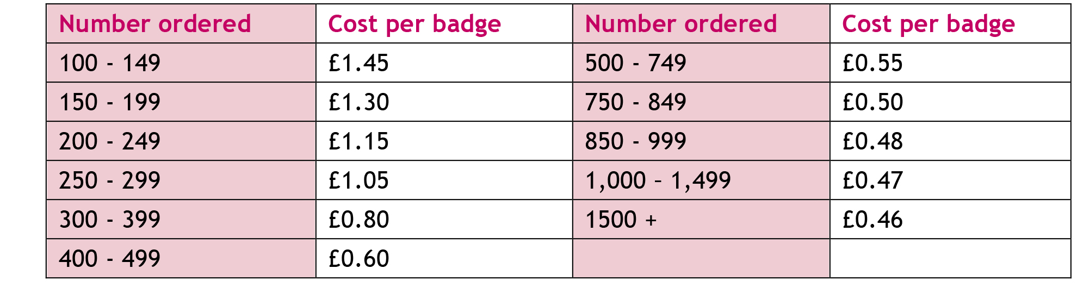

Your order
RAN1 – Camp  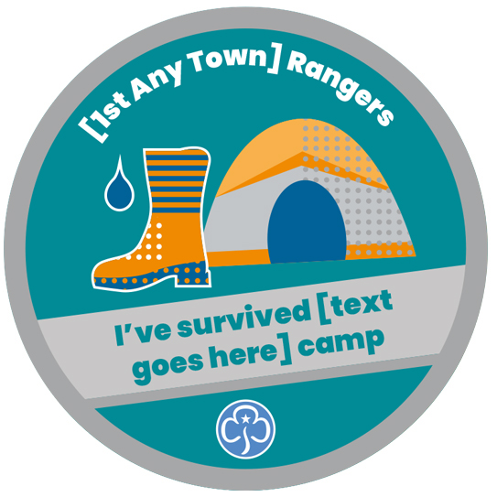 | Quantity
Date required (dd/mm/yyyy)
We’ll aim to deliver by this date, but cannot guarantee it.
 | Personalisation – unit/district/division name
 | Personalisation – event name

RAN2 - Stars  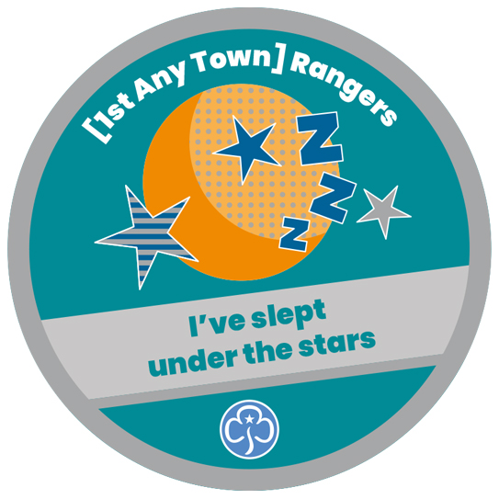 | Quantity
Date required (dd/mm/yyyy)
We’ll aim to deliver by this date, but cannot guarantee it.
 | Personalisation – unit/district/division name

RAN3 – Happy birthday  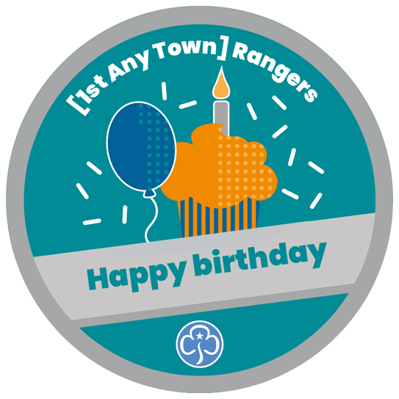 | Quantity
Date required (dd/mm/yyyy)
We’ll aim to deliver by this date, but cannot guarantee it.
 | Personalisation – unit/district/division name

RAN4 – Festival  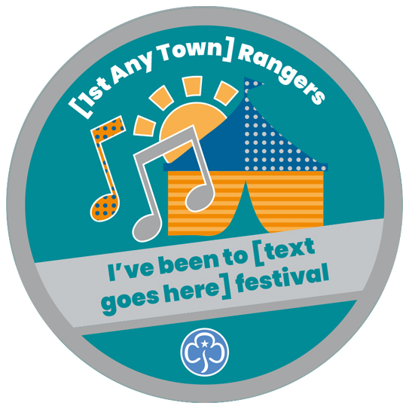 | Quantity
Date required (dd/mm/yyyy)
We’ll aim to deliver by this date, but cannot guarantee it.
 | Personalisation – unit/district/division name
 | Personalisation – event name

RAN5 – Sea  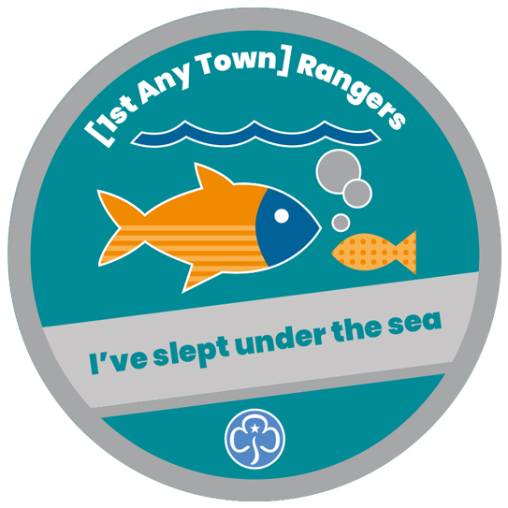 | Quantity
Date required (dd/mm/yyyy)
We’ll aim to deliver by this date, but cannot guarantee it.
 | Personalisation – unit/district/division name

RAN6 - Sporty  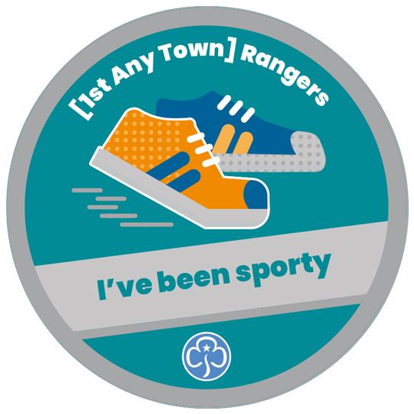 | Quantity
Date required (dd/mm/yyyy)
We’ll aim to deliver by this date, but cannot guarantee it.
 | Personalisation – unit/district/division name

RAN7 - Community  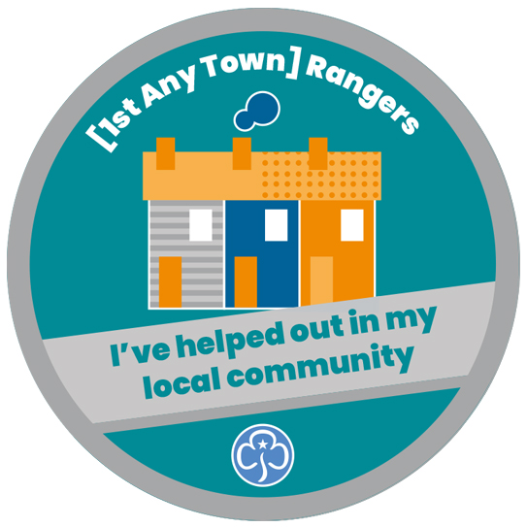 | Quantity
Date required (dd/mm/yyyy)
We’ll aim to deliver by this date, but cannot guarantee it.
 | Personalisation – unit/district/division name

RAN8 - Talent show  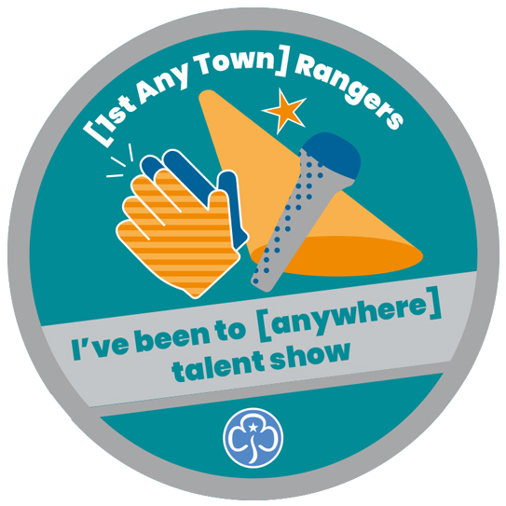 | Quantity
Date required (dd/mm/yyyy)
We’ll aim to deliver by this date, but cannot guarantee it.
 | Personalisation – unit/district/division name
 | Personalisation – event name

Please note, once confirmation has been received you cannot cancel or return orders made to your specification unless they are faulty.
To read our full delivery and returns information please go to girlguidingshop.co.uk.
For all return enquiries, email us at bespoke@girlguiding.org.uk or give us a ring
on 0161 941 2237.

Signed
We accept electronic signatures.
Date (dd/mm/yyyy)

Once completed please return this form by email to bespoke@girlguiding.org.uk.

