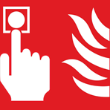 |  | Sound the alarm by operating the nearest fire alarm call point
 |  | Dial 999 to call the Fire Brigade
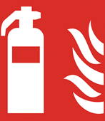 |  | If it is safe to do so, attempt to put out the fire using the appliances provided.
 |  | Isolate the gas to the oven by operating the gas isolation button
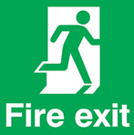 |  | Leave the building by the nearest available point
Report to Primary evacuation point at:
Primary Evacuation Point:

Secondary Evacuation Pint:
 |  | Do not stop to collect personal belongings
Example Emergency Evacuation plan

