Display screen equipment (DSE) workstation checklist
Each workstation with DSE – such as computers, laptops or CCTV screens – should be reviewed using this checklist.

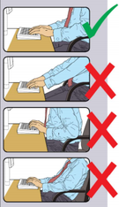
Keyboard
Name of person completing assessment:
Location of workstation: |  |  | Date: | / /
Is it possible to find a comfortable typing position?  Try pushing the keyboard back to make more room for the keyboard, hands and wrists. | Yes  No
If no, what action are you taking?

Do users have good typing technique?  Their hands shouldn’t be bent up at wrist, and they shouldn’t hit the keys too hard or overstretch their fingers. | Yes  No
If no, what action are you taking?

Are all the characters on the keyboard clear and readable?  Keyboards should be kept clean. If some of the characters still can’t be read even after cleaning, then you may need a new keyboard. | Yes  No
If no, what action are you taking?

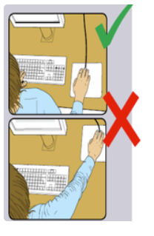
Mouse/trackball
Is the mouse close enough to the user?  Generally, it’s best to put the mouse right next to the user, on the side of their dominant hand. Users shouldn’t overreach or leave their hand on the mouse when they’re not using it. They should be encouraged to have a relaxed arm and straight wrist. | Yes  No
If no, what action are you taking?

Is there support for the user’s wrist and forearm?  The desk surface or chair arm can provide support. The user needs to be comfortable when using the device. Consider whether they need a wrist support. | Yes  No
If no, what action are you taking?

Does the mouse work smoothly at a speed that suits the user?  Check if the mouse ball or rollers need to be cleaned. Check the work surface is suitable – a mouse mat might be needed. | Yes  No
If no, what action are you taking?

Can the user easily adjust the speed and accuracy of the pointer using software settings?  Users may need training in how to adjust mouse settings. | Yes  No
If no, what action are you taking?

Display screens
Are the characters clear and readable?  Make sure the screen is clean and cleaning materials are available.  Check the text and background colours work well together. | Yes  No
If no, what action are you taking?

Is the image stable, ie free from flickering and juddering?  Try using different colours to decrease/remove flickering. For example, try a darker background and lighter text. | Yes  No
If no, what action are you taking?

Does the screen swivel and tilt so you can adjust it to the correct position?  The screen may need replacing if you can’t move it to the correct position | Yes  No
If no, what action are you taking?

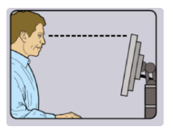

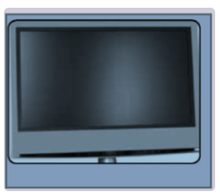
Is the screen free from glare and reflections?  Place a mirror in front of the screen to check where reflections are coming from.  You might need to move the screen or even the desk to shield the screen from reflections.  Using dark characters on a lighter background can help.  You might need something to screen windows, like a blind. | Yes  No
If no, what action are you taking?

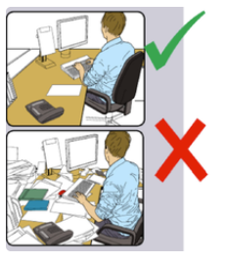
Furniture
Is the work surface large enough for all the paperwork and equipment you use?  Create more room, for example by moving printers etc elsewhere.  Consider installing new power and telephone sockets so items can be moved. | Yes  No
If no, what action are you taking?

Can the user comfortably reach everything they need?  Rearrange things to bring the most frequently used items closer to the user.  A document holder may be needed to hold papers and avoid uncomfortable head and eye movements. | Yes  No
If no, what action are you taking?

Are surfaces free from glare and reflection?  Consider mats and blotters to reduce glare and reflection. | Yes  No
If no, what action are you taking?

Is the chair suitable and in good condition?  The chair should be stable with working back and seat, height and lift adjustments and fitted with castors or glides. It may need repair or replacement if it’s uncomfortable and can’t be properly adjusted. | Yes  No
If no, what action are you taking?

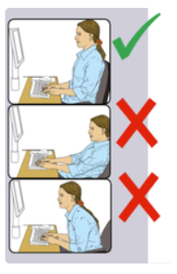
Furniture – continued
Is the chair adjusted correctly?  The user should be able to carry out their work sitting comfortably.  NB The arms of chairs can stop the chair being close enough to the worktop to use the equipment comfortably.  Move any obstructions from under desks. | Yes  No
If no, what action are you taking?

Does the chair’s back rest support the small of the back?  The user should have a straight back, supported by the chair, with relaxed shoulders. | Yes  No
If no, what action are you taking?

Are the forearms horizontal and the eyes roughly at the same height as the top of the screen?  Adjust the chair height to get the arms in the right position and then adjust the screen height, if necessary. | Yes  No
If no, what action are you taking?

Are the feet flat on the floor without too much pressure form the seat on the back of the legs?  If not, a footrest might be needed. | Yes  No
If no, what action are you taking?

Environment
Is there enough room to change position and vary movement?  Space is needed to move and stretch.  Cables should be tidy and not a trip or snag hazard. | Yes  No
If no, what action are you taking?

Is the lighting suitable, for example not too bright or dim to work comfortably?  Consider shading or repositioning light sources or providing local lighting, for example a desk lamp. But be careful to avoid glare. | Yes  No
If no, what action are you taking?

