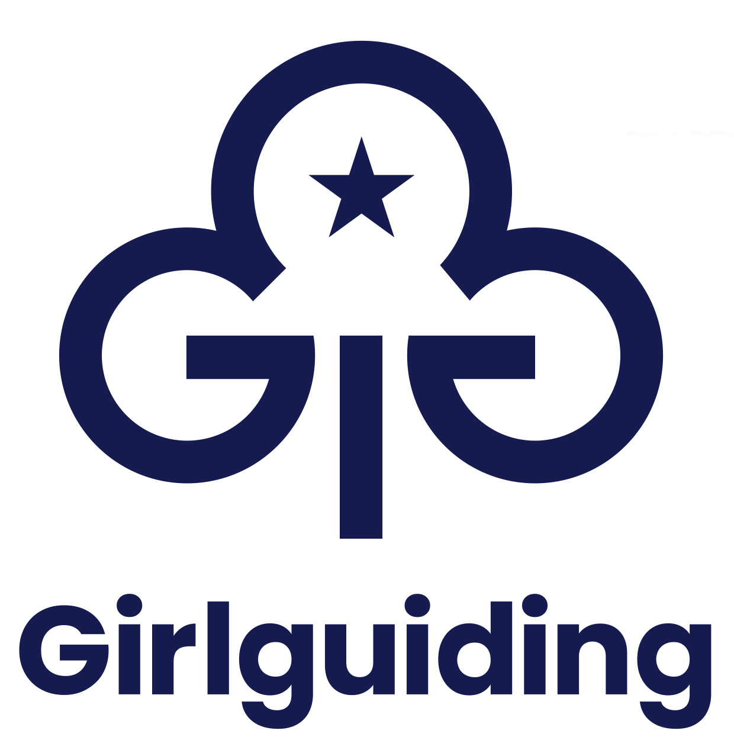
Adjustment plan for volunteers – events
Being inclusive is one of our core values at Girlguiding. An adjustment plan is a practical tool to help remove barriers by identifying and recording adjustments. So all our volunteers can get the most out of their guiding experience.
Before completing the adjustment plan, please read through our guidance on making adjustments.
Make sure you have completed the general adjustment plan before completing this plan.
Work together with the team attending the event and support/carers (if relevant) to complete this form.
Name of volunteer:
Membership number:
Name of event:
Date(s) of event:
Person responsible for first aid at the event (if known):

Section 1: Additional information
1. Do you use any equipment? Do you need any help with using/managing your equipment for this event?

Medication name | Dosage | Frequency

2. If relevant, what medication do you take? (Please include dosage and frequency.)
3. Who can administer/use this medication, and is specialist training needed?
4. Where should your medication/equipment be kept during the event?
5. What changes might the volunteer team need to make for this event?
Use this section to tell us about any support you need with:
- Toileting
- Dressing and undressing

- Sleep and bedtime
- Eating and drinking
- Washing and bathing

6. Is there anything else that you or your support/carer would like to share about how to best support you at this event?

Section 2: Making adjustments
1. Please note the adjustments agreed for this event

Section 3: Sign off
Volunteer and parent/carer (if volunteer is under 18 – or under 16 in Scotland):
Everyone should feel welcome and included in Girlguiding. This plan will help to make adjustments and remove any barriers so you can participate in guiding activities.
By signing, I agree:
- The information given on this form is accurate, to the best of my knowledge, at the time of writing.
- I’m comfortable with the adjustments agreed in this plan and I’m comfortable for Girlguiding volunteers to make the adjustments agreed.
- Girlguiding HQ may be contacted for further support about the adjustments agreed in this plan.
Signature of volunteer:
Date:
Signature of parent/carer (if volunteer is under 18 – or under 16 in Scotland):
Date:

Person making adjustments eg, unit leader/first aider/commissioner:
By signing, I agree:
- The information given on this form is accurate, to the best of my knowledge, at the time of writing.
- I’m comfortable with the adjustments agreed in this plan.
- I agree to follow this plan as best as I can, and will seek further support if I need it.
Name and role of person who will be making the adjustments agreed in this plan:
Signature: | Date:
Please follow our managing information procedure to make sure any personal data on this form is managed safely and legally.
If you need more support, please get in touch with your division commissioner or contact our volunteer support team at HQ by email: volunteersupport@girlguiding.org.uk

