Welcome to

Guides

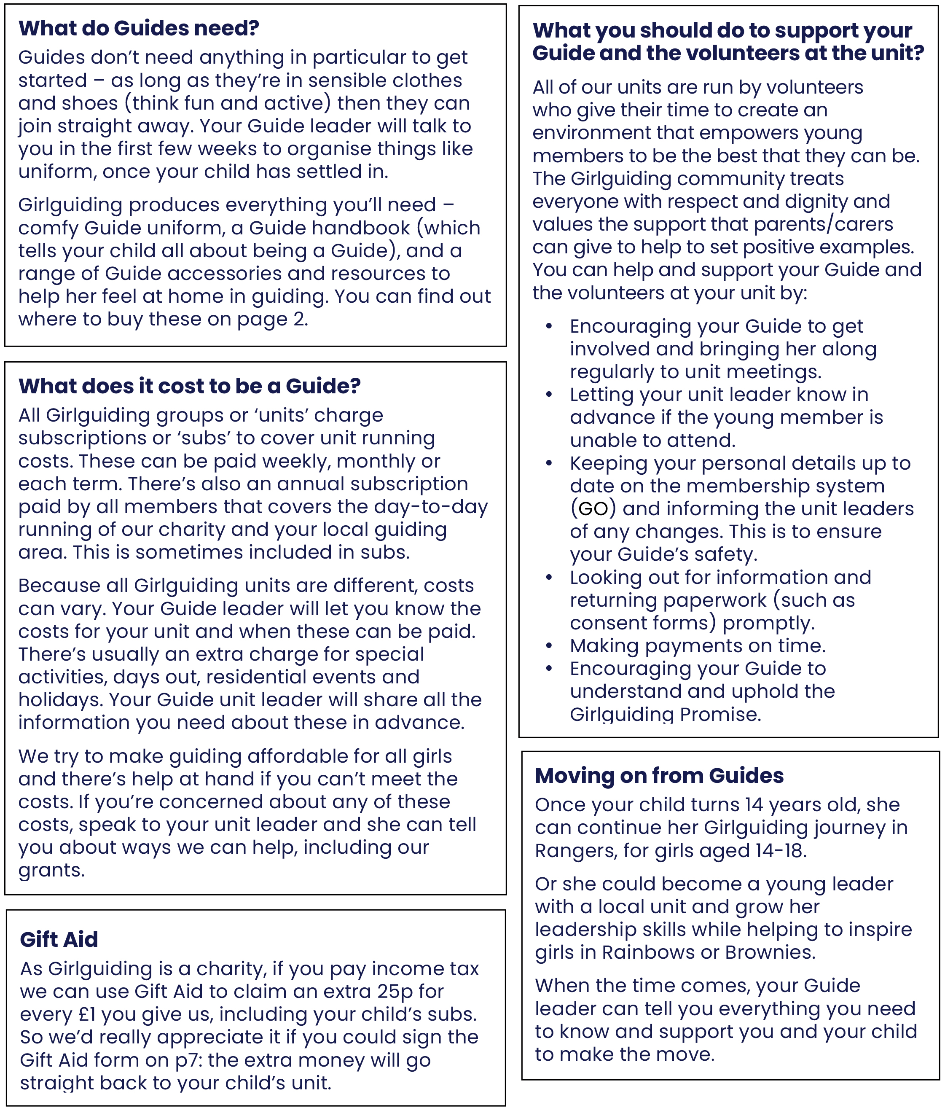**Guides is a relaxed, welcoming space where you can have fun, learn and be yourself with good friends from 10 to 14 years old. Find out more about Guides** [on our website.](https://www.girlguiding.org.uk/what-we-do/guides/)

**Unit details**

|  |  |
| --- | --- |
| Unit name |  |
| Meeting place |  |
| Meeting day/time |  |
| Unit email (if applicable) |  |
| Unit social media (if applicable) |  |

**Unit subscription details**

|  |  |  |  |  |  |
| --- | --- | --- | --- | --- | --- |
| How often it is paid |  | | How much | |  |
| Your child’s subscription (please check one) | includes | excludes | | partly pays for | |
| the Girlguiding annual membership subscription | | | | |
| You can pay it by |  | | | | |

**Leader details**

|  |  |  |  |
| --- | --- | --- | --- |
| Unit main contact |  | | |
| Phone number(s) |  | | |
| Email |  | | |
| Unit secondary contact |  | | |
| Phone number(s) |  | Email |  |

**Area support**Your child’s unit is part of a wider Girlguiding family.

|  |  |  |
| --- | --- | --- |
| The unit is part of |  | District and/or Division |
|  | County |
|  | Country/Region |

**Local commissioner**

|  |  |
| --- | --- |
| Name |  |
| Phone number(s) |  |
| Email |  |

We take your concerns seriously. If you ever need to talk about an issue with someone other than your unit leader, contact the local commissioner in the first instance. Or you can contact us at [www.girlguiding.org.uk/about-us/contact-us](http://www.girlguiding.org.uk/about-us/contact-us).

**Buying Girlguiding uniform, gifts and resources**

To find your nearest Girlguiding or volunteer shop ask your leader, call 0161 941 2237 or visit girlguidingshop.co.uk > [Find a Volunteer Shop](https://www.girlguidingshop.co.uk/find-a-volunteer-shop/). You can buy your guiding essentials online at [girlguidingshop.co.uk](http://www.girlguidingshop.co.uk). To order by phone from your latest Guiding Essentials catalogue call   
0161 941 2237. For any buying queries please email us at [tradingshop@girlguiding.org.uk](mailto:tradingshop@girlguiding.org.uk)

|  |  |
| --- | --- |
| Your local shop |  |

**Parents and carers: once completed, please keep pages 1 and 2 for your information.**

**Essential information**

It’s essential the information we collect, store and use for your child’s membership is   
accurate. Please tell the unit leaders about any changes and keep your personal details   
up to date on our membership system GO. You can find our parent and carers' guide to   
GO [on our website](https://www.girlguiding.org.uk/information-for-parents/parent-and-carers-guide-to-go/).

|  |  |
| --- | --- |
| Young person’s name |  |
| Young person’s preferred name |  |
| Young person’s date of birth | /     / |

**Parent/carer details** – required

This must be the person who has legal responsibility for this member. This person must sign this form.

|  |  |
| --- | --- |
| Name |  |
| Relationship to young person |  |
| Address |  |
| Phone number(s) |  |
| Email |  |

**Health information**

To make sure your child is able to participate and enjoy a range of guiding opportunities during her membership, we ask that you complete the following health information. Any information that you give about a child’s disabilities or health condition will be used to help volunteers make guiding more accessible for your child. We recommend that you speak to your unit leader about support and adjustments the unit can provide.

Please tell your leader if there is anything else happening in your Guide’s life which will help our volunteers to support her and look after her safety.

**Required information**

|  |  |  |
| --- | --- | --- |
| Do you consider your child to be disabled or to have a health condition? This could include physical impairments, learning difficulties or disabilities, mental health difficulties, sensory impairments, or any other medical conditions including epilepsy, asthma and diabetes. If your child would benefit from adjustments in order to help her participate fully please also see our [adjustment plans on our website.](https://www.girlguiding.org.uk/information-for-volunteers/running-your-unit/including-all/including-members-with-additional-needs/making-reasonable-adjustments/) | | Yes  No |
| Disabilities, health conditions or medication |  | |

**Note:** There will always be at least one person at every unit meeting, activity or event with a valid first aid qualification. If you have any questions or concerns about this, please speak to the unit leader. Please label any medication with your child’s name and provide clear instructions for its use. If applicable, ensure that a spare, clearly labelled inhaler or adrenaline auto-injector is brought to the event to be held by the first aider.

**Leaders: once completed, please ensure the information on pages 3,4 and 5 is recorded on GO.   
Paper copies should be securely destroyed.**

**Health information** - continued

Unit meeting activities can often involve equipment, materials and food. So please add any allergies or dietary requirements here.

|  |  |
| --- | --- |
| Allergies | Dietary requirements |
|  |  |

**Photo preferences** - required

We sometimes take photos and/or videos during our activities. Please let us know your preference for the way in which we can use photos of your child. **Choose one option only.**

|  |
| --- |
| **[a]** ‘Photos/videos can be shared and published and used for marketing - this means I am happy for photos, videos, storytelling and other visual and audio content of my child to be taken/collected, used for promotional and marketing purposes, published in public-facing media and shared within Girlguiding and with partners and local newspapers’.  **[b]** ‘Photo/videos can be used for unit use only - this means I am happy for photos, videos, storytelling and other visual and audio content of my child to be taken/collected, used as a record of unit activities, not published in any public-facing media and not shared outside the unit’. This may include unit specific social media channels (that are closed to the public).  **[c]** ‘Do not take photo/videos - this means I do not want photos, videos, storytelling and other visual and audio content featuring my child to be taken’. |

Photo/video permissions differ for large scale events (where over 100 participants are present). Consent forms will state clearly if an event is large scale, and will request parents/carers to tell leaders if they don’t wish photos/videos of their child to be taken at the event.

**Communications**

To deliver good quality guiding, local leaders will need to communicate with members or young member’s parents/carers. We need to be able to tell you information about planned activities so that together we can participate in great local guiding. The unit leader may also need to contact you about any last minute changes to our plans. Please speak to your unit leader to find out more.

**Phone number**

|  |
| --- |
| I’m happy for my child’s leader to save my telephone number on her personal mobile phone. |

**Transport arrangements** – required

Nothing is more important than your child’s safety, so we need to know who’ll be accompanying her to and from meetings. If this information changes, or if there’s someone who shouldn’t be accompanying your child, please tell your leader immediately. When dropping off, please make sure that there’s a responsible adult present before you leave.

|  |  |
| --- | --- |
| Dropping off |  |
| Picking up |  |

Please tell us which school your Guide attends

|  |
| --- |
| School: |

**Leaders: once completed, please ensure the information on pages 3,4 and 5 is recorded on GO.   
Paper copies should be securely destroyed.**

**Additional parent/carer details**

Please give details of your child’s 2nd and 3rd parents or carers if applicable

**2nd parent/carer details** – optional

|  |  |
| --- | --- |
| Name |  |
| Relationship to young person |  |
| Address |  |
| Phone number(s) |  |
| Email |  |

**3rd parent/carer details** – optional

|  |  |
| --- | --- |
| Name |  |
| Relationship to young person |  |
| Address |  |
| Phone number(s) |  |
| Email |  |

**Emergency contact details**

Emergency contact(s) should be available during unit meeting times, but we’ll always try to contact a parent/carer first in an emergency. It’s best to choose two people who don’t live together to maximise the chance of getting hold of someone immediately.

**1st emergency contact details** – required

|  |  |
| --- | --- |
| Name |  |
| Relationship to young person |  |
| Address |  |
| Phone number(s) |  |

**2nd emergency contact details** – optional

|  |  |
| --- | --- |
| Name |  |
| Relationship to young person |  |
| Address |  |
| Phone number(s) |  |

**Leaders: once completed, please ensure the information on pages 3,4 and 5 is recorded on GO.   
Paper copies should be securely destroyed.**

**Volunteering**

Girlguiding wouldn’t exist without our volunteers. Every extra adult helping out makes a massive difference – is this something you’d consider?

|  |  |  |  |
| --- | --- | --- | --- |
| Could you help at meetings? | Regularly | Occasionally | Never |
| Can you help occasionally with any of the following? | Transport | Activities | Camps or holidays |
| Other - if you have interests, skills, equipment or anything else that you’d be prepared to share with your Guide unit at some point, we’d love to hear from you. Let us know here. | |  | |
| You can also register your interest to volunteer on our website at Girlguiding.org.uk/interested | | | |

**Confirmation**

As part of the Girlguiding programme, your child will take part in varied activities. The unit may visit indoor and outdoor spaces local to the unit meeting place during unit meetings. The unit leadership team will let you know about these activities ahead of time and risk assess them. By allowing your child to attend a unit meeting, you consent to their participation in any planned activities. If you have any questions or concerns about any planned activities, please speak to the unit leadership team. You’ll be asked to give additional parent or carer consent for adventurous activities, activities outside unit meeting times, day trips and residential stays.

I confirm that the information that I’ve provided for this form is correct at the time provided and that I’ve read the information about supporting my child and the unit volunteers. I’m happy for Girlguiding to contact me in the ways I’ve indicated above. I understand that the Girlguiding community treats everyone with respect and dignity and I understand my role in helping to uphold the values of Girlguiding.

|  |  |
| --- | --- |
| Name of child |  |
| Signature of parent/carer* |  |
| Date |  |

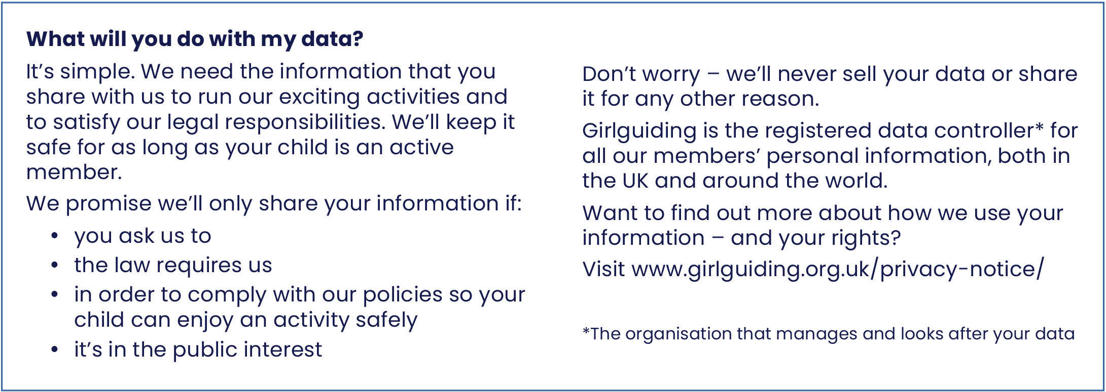*Both electronic and wet ink signatures are acceptable

**Leaders: once completed, this page should be kept in a secure location   
for the duration of membership +1 year.**

**Gift Aid declaration**

We have the opportunity to boost the money going into our unit by as much as 25%.

Due to government legislation on Gift Aid, we can claim back 25p for every £1 of the money you donate - including your child’s subscription. Gift Aid is reclaimed by the charity from the tax you pay for the current tax year. Your address is needed to identify you as a current UK taxpayer.

|  |
| --- |
| Young member’s name: |

In order to Gift Aid your donation you must complete the following:

|  |  |  |  |
| --- | --- | --- | --- |
| I want to Gift Aid donations made | **Please tick all that apply** | | |
| In the past 4 years | Today | In the future |

**Leaders: please fill in your unit name and unit charity number** (if applicable)

For England and Wales, this is only applicable if your unit is registered as an individual charity with the Charity Commission. For Scotland and Northern Ireland, you must include your charity number.

|  |  |
| --- | --- |
| Unit name (required) |  |
| Unit charity number (if applicable) |  |

**Donor’s details**

|  |  |  |  |
| --- | --- | --- | --- |
| Title |  | | |
| First name |  | | |
| Surname |  | | |
| Address |  | | |
| Signature* |  | | |
| Post code |  | Date |  |
| I am a UK taxpayer and understand that if I pay less income tax and/or capital gains tax than the amount of Gift Aid claimed on all my donations in that tax year, it is my responsibility to pay any difference. | | | |

*Both electronic and wet ink signatures are acceptable

**Please notify your Girlguiding leader if you:**

* Want to cancel this declaration
* Change your name or home address
* No longer pay sufficient tax on your income and/or capital gains

If you pay income tax at the higher rate or additional rate and want to receive additional tax relief, you must include all your Gift Aid donations on your self-assessment tax return or ask HM Revenue and Customs to adjust your tax code.

**Leaders: once completed this page should be kept in a secure location   
for 7 years after the last claim made.**