Welcome to



Girlguiding

**New starter form to be completed by parents/carers of young members aged 14-17 years. Find out about** [**Rangers**](https://www.girlguiding.org.uk/what-we-do/rangers/)**,** [**young leaders**](https://www.girlguiding.org.uk/get-involved/become-a-volunteer/young-volunteers/young-leader/) **and** [**young external volunteers**](https://www.girlguiding.org.uk/get-involved/become-a-volunteer/young-volunteers/young-external-volunteer/) **on our website.**

**Unit details**

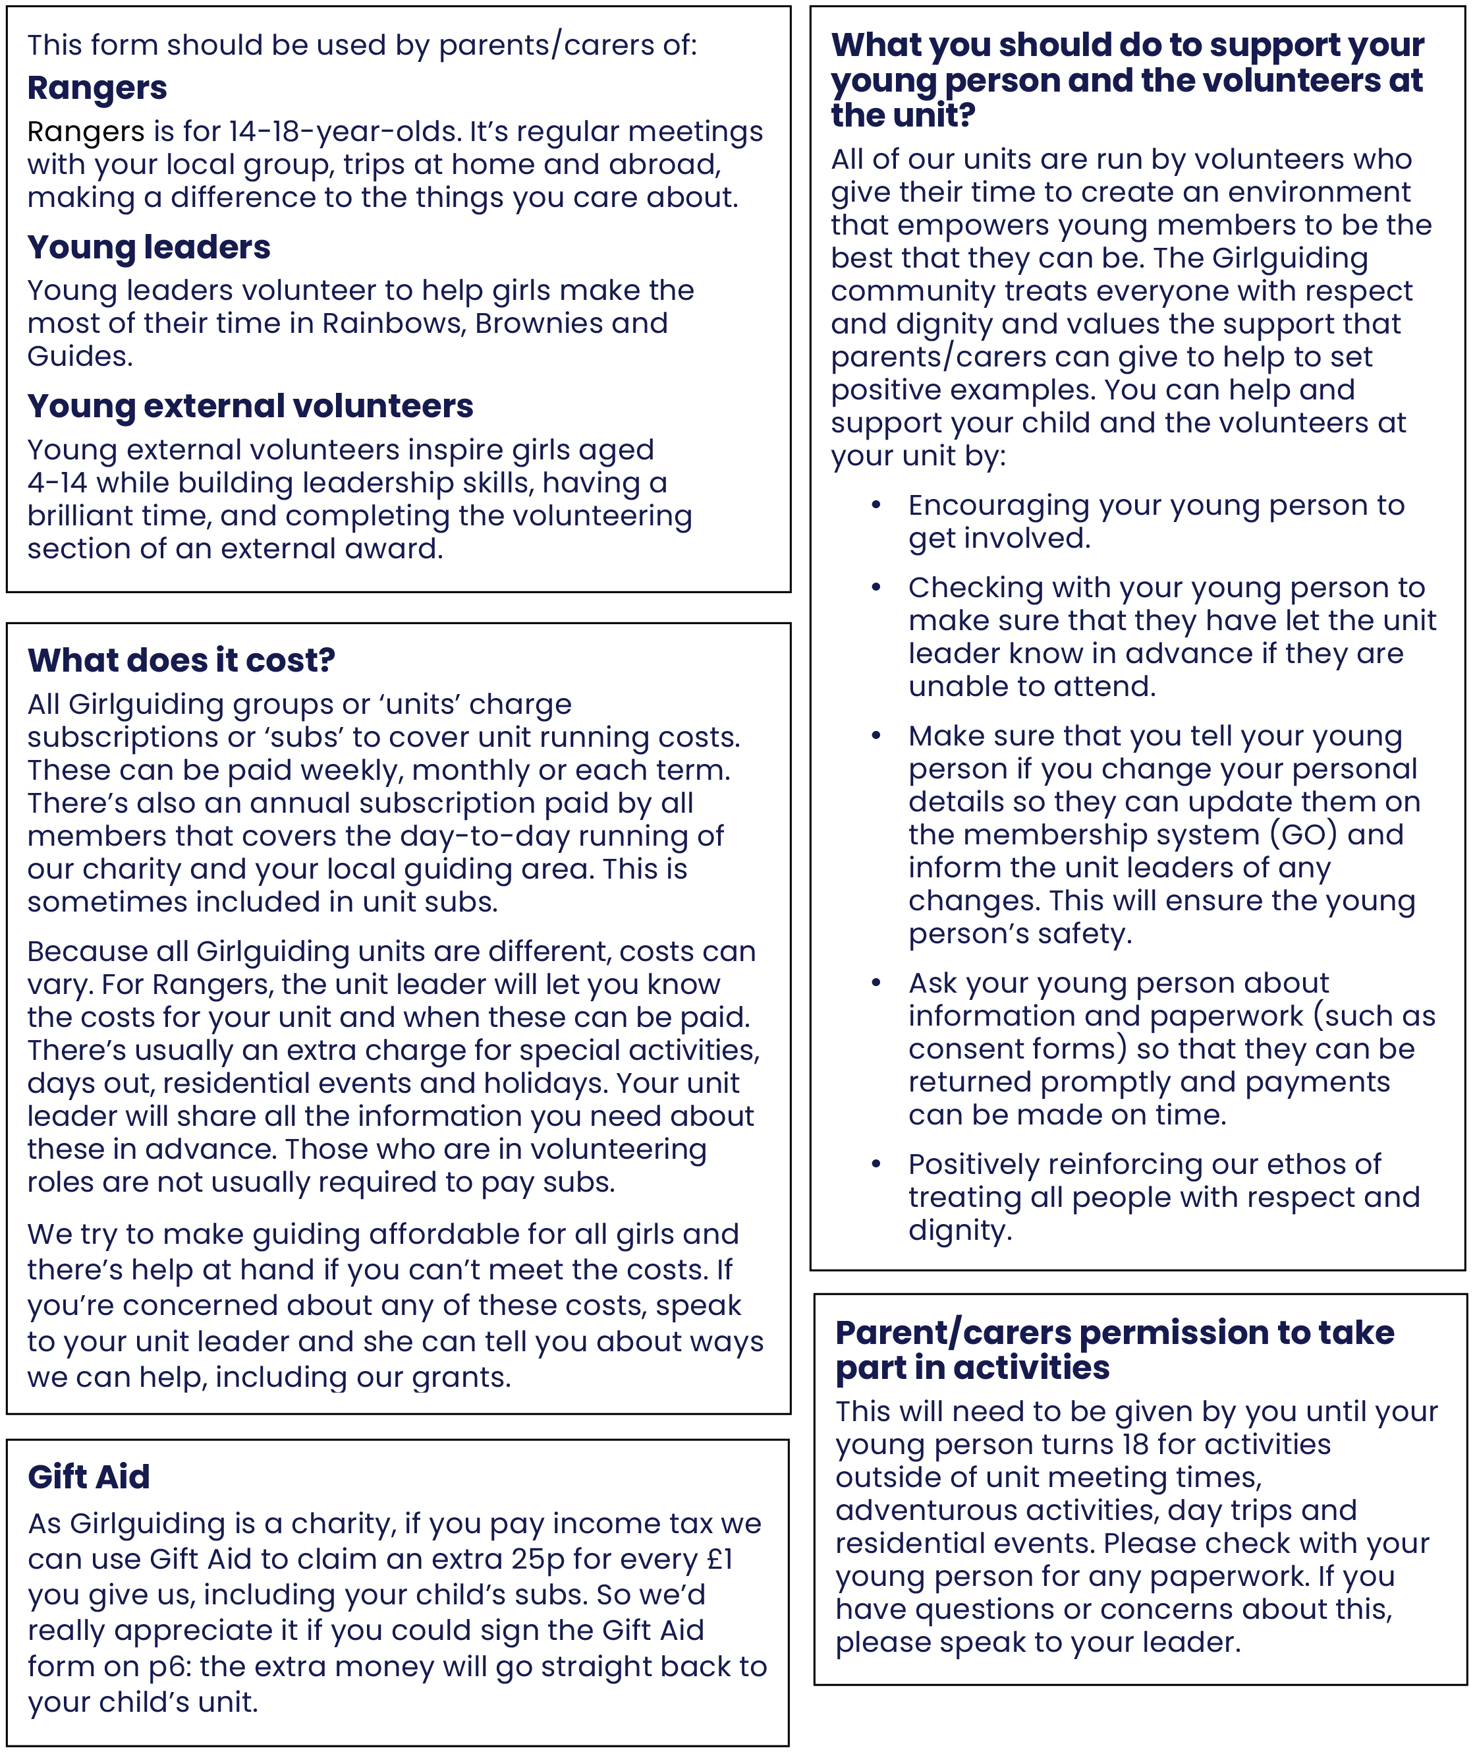

The sections on this page should be filled in as appropriate for Rangers, young leaders and   
young external volunteers.

|  |  |
| --- | --- |
| Unit name |  |
| Meeting place |  |
| Meeting day/time |  |
| Unit email (if applicable) |  |
| Unit social media (if applicable) |  |

**Unit subscription details**

|  |  |  |  |  |  |
| --- | --- | --- | --- | --- | --- |
| How often it is paid |  | | How much | |  |
| Your child’s subscription (please check one) | includes | excludes | | partly pays for | |
| the Girlguiding annual membership subscription | | | | |
| You can pay it by |  | | | | |

**Leader details**

|  |  |  |  |
| --- | --- | --- | --- |
| Unit main contact |  | | |
| Phone number(s) |  | | |
| Email |  | | |
| Unit secondary contact |  | | |
| Phone number(s) |  | Email |  |

**Area support**

Your child’s unit is part of a wider Girlguiding family.

|  |  |  |
| --- | --- | --- |
| The unit is part of |  | District and/or Division |
|  | County |
|  | Country/Region |

**Local commissioner**

|  |  |  |  |
| --- | --- | --- | --- |
| Name |  | | |
| Phone number(s) |  | Email |  |

We take your concerns seriously. If you ever need to talk about an issue with someone other than your unit leader, contact the local commissioner in the first instance. Or you can contact us at [www.girlguiding.org.uk/about-us/contact-us](http://www.girlguiding.org.uk/about-us/contact-us).

**Buying Girlguiding uniform, gifts and resources**

To find your nearest Girlguiding or volunteer shop ask your leader, call 0161 941 2237 or visit girlguidingshop.co.uk > [Find a Volunteer Shop](https://www.girlguidingshop.co.uk/find-a-volunteer-shop/). You can buy your guiding essentials online at [girlguidingshop.co.uk](http://www.girlguidingshop.co.uk). To order by phone from your latest Guiding Essentials catalogue call   
0161 941 2237. For any buying queries please email us at [tradingshop@girlguiding.org.uk](mailto:tradingshop@girlguiding.org.uk)

|  |  |
| --- | --- |
| Your local shop |  |

**Parents and carers: please keep pages 1 and 2 for your information.**

**Essential information**

The email address should belong to the young person so that they can manage their information on GO.

|  |  |
| --- | --- |
| Young person’s name |  |
| Young person’s email |  |

**Parent/carer details** – required

This must be the person who has legal responsibility for this member. This person must sign this form.

|  |  |
| --- | --- |
| Name |  |
| Relationship to young person |  |
| Address |  |
| Phone number(s) |  |
| Email |  |

**Additional information**

In addition to the information that you have supplied on this form your young person has been asked to complete the following information (as appropriate) on the Girlguiding membership system ([GO](https://go.girlguiding.org.uk/)).

They can login at [go.girlguiding.org.uk](https://go.girlguiding.org.uk/) where they will also find help guides for filling in their information:

* Full name, preferred name and date of birth
* Home address, email address, telephone numbers (mobile and/or landline)
* Parent/carer details and an emergency contact
* School
* Details about how they get to and from unit meetings
* Any relevant health information
* Photo preferences

It is very important for the safety of everyone involved with Girlguiding that all these details are kept up to date. In order to maintain this we ask that you check with your young person that these are correct and make sure that any changes to your details are communicated to your young person and the unit leader (if appropriate).

**Communications**

To deliver good quality guiding, local leaders will need to communicate with members or young member’s parents/carers. We need to be able to tell you information about planned activities so that together we can participate in great local guiding. The unit leader may also need to contact you about any last minute changes to our plans. Please speak to your unit leader to find out more.

**Phone number**

|  |
| --- |
| I’m happy for my child’s leader to save my telephone number on her personal mobile phone. |

**Leaders: once completed, please ensure the information on pages 3 and 4 is recorded on GO.   
Paper copies should be securely destroyed.**

**Additional parent/carer details**

Please give details of your child’s 2nd and 3rd parents or carers if applicable

**2nd parent/carer details** – optional

|  |  |
| --- | --- |
| Name |  |
| Relationship to young person |  |
| Address |  |
| Phone number(s) |  |
| Email |  |

**3rd parent/carer details** – optional

|  |  |
| --- | --- |
| Name |  |
| Relationship to young person |  |
| Address |  |
| Phone number(s) |  |
| Email |  |

**Emergency contact details**

Emergency contact(s) should be available during unit meeting times, but we’ll always try to contact a parent/carer first in an emergency. It’s best to choose two people who don’t live together to maximise the chance of getting hold of someone immediately.

**1st emergency contact details** – required

|  |  |
| --- | --- |
| Name |  |
| Relationship to young person |  |
| Address |  |
| Phone number(s) |  |

**2nd emergency contact details** – optional

|  |  |
| --- | --- |
| Name |  |
| Relationship to young person |  |
| Address |  |
| Phone number(s) |  |

**Leaders: once completed, please ensure the information on pages 3 and 4 is recorded on GO.   
Paper copies should be securely destroyed.**

**Volunteering**

Girlguiding wouldn’t exist without our volunteers. Every extra adult helping out makes a massive difference – is this something you’d consider?

|  |  |  |  |
| --- | --- | --- | --- |
| Could you help at meetings? | Regularly | Occasionally | Never |
| Can you help occasionally with any of the following? | Transport | Activities | Camps or holidays |
| Other - if you have interests, skills, equipment or anything else that you’d be prepared to share with your unit at some point,  we’d love to hear from you. Let  us know here. |  | | |
| You can also register your interest to volunteer on our website at Girlguiding.org.uk/interested | | | |

**Confirmation**

As part of the Girlguiding programme, your child will take part in varied activities. The unit may visit indoor and outdoor spaces local to the unit meeting place during unit meetings. The unit leadership team will let you know about these activities ahead of time and risk assess them. By allowing your child to attend a unit meeting, you consent to their participation in any planned activities. If you have any questions or concerns about any planned activities, please speak to the unit leadership team. You’ll be asked to give additional parent or carer consent for adventurous activities, activities outside unit meeting times, day trips and residential stays.

I confirm that the information that I’ve provided for this form is correct at the time provided and that I’ve read the information about supporting my child and the unit volunteers. I’m happy for Girlguiding to contact me in the ways I’ve indicated above. I understand that the Girlguiding community treats everyone with respect and dignity and I understand my role in helping to uphold the values of Girlguiding.

|  |  |
| --- | --- |
| Name of child |  |
| Signature of parent/carer* |  |
| Date |  |

*Both electronic and wet ink signatures are acceptable

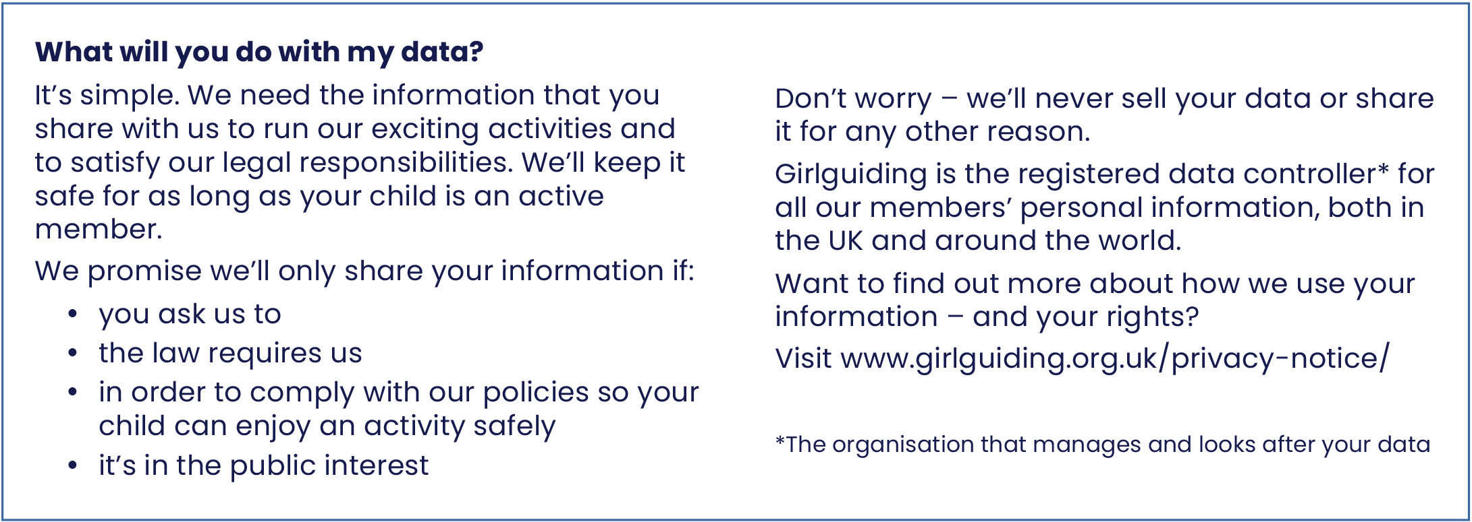

**Leaders: once completed, this page should be kept in a secure location   
for the duration of membership +1 year.**

**Gift Aid declaration**

We have the opportunity to boost the money going into our unit by as much as 25%.

Due to government legislation on Gift Aid, we can claim back 25p for every £1 of the money you donate - including your child’s subscription. Gift Aid is reclaimed by the charity from the tax you pay for the current tax year. Your address is needed to identify you as a current UK taxpayer.

|  |
| --- |
| Young member’s name: |

In order to Gift Aid your donation you must complete the following:

|  |  |  |  |
| --- | --- | --- | --- |
| I want to Gift Aid donations made | **Please tick all that apply** | | |
| In the past 4 years | Today | In the future |

**Leaders: please fill in your unit name and unit charity number** (if applicable)

For England and Wales, this is only applicable if your unit is registered as an individual charity with the Charity Commission. For Scotland and Northern Ireland, you must include your charity number.

|  |  |
| --- | --- |
| Unit name (required) |  |
| Unit charity number (if applicable) |  |

**Donor’s details**

|  |  |  |  |
| --- | --- | --- | --- |
| Title |  | | |
| First name |  | | |
| Surname |  | | |
| Address |  | | |
| Signature* |  | | |
| Post code |  | Date |  |
| I am a UK taxpayer and understand that if I pay less income tax and/or capital gains tax than the amount of Gift Aid claimed on all my donations in that tax year, it is my responsibility to pay any difference. | | | |

*Both electronic and wet ink signatures are acceptable

**Please notify your Girlguiding leader if you:**

* Want to cancel this declaration
* Change your name or home address
* No longer pay sufficient tax on your income and/or capital gains

If you pay income tax at the higher rate or additional rate and want to receive additional tax relief, you must include all your Gift Aid donations on your self-assessment tax return or ask HM Revenue and Customs to adjust your tax code.

**Leaders: once completed this page should be kept in a secure location   
for 7 years after the last claim made.**