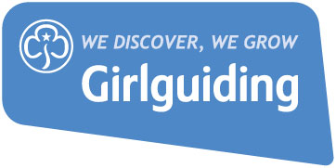

Template for an honest conversation

This is intended as a guide for the conversation and should not be used as a script. Base your questions on the specific situation you are in and the needs of the volunteer – you don’t need to include points that are not appropriate.

Why did you contact the volunteer – what’s the reason for your meeting?

How are they doing? Has anything changed in their circumstances that would be impacting on the issue you have contacted them about?

How are they enjoying their role? What do they like best about it?

What responsibilities are included within their role?
- Are they able to do everything asked of them? Be specific.
- Which of these responsibilities could be done by someone else in the team?
- If the role needs to be reduced, which areas would they like to let go of?

What support would they like to be put into place? This could include training, additional volunteers, taking a break, a buddy/mentor etc.

Are there other roles available that would better suit them? Perhaps they could change section, volunteer more casually or take on a less time-intensive role.

What are your agreed actions - who will do these and by which date?

Date of next catch up

