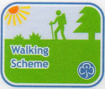
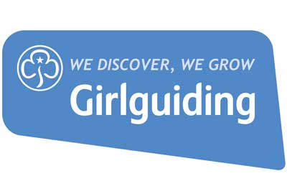

Leisure Walking Week 2022

16 – 22 October in Glenshee, Scotland

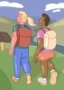
Would you like to:
- Enjoy a walk for pleasure in Scotland with like-minded people
- Complete a Logbook walk or Quality Mountain Day towards your walking qualification or renewal
- Extend your existing walking skills and gain experience of walking in your chosen level of countryside with support from other experienced walkers
- Share walking information and experience with other leaders
- Find out more about the Girlguiding Walking Scheme

If the answer to any of the above is ‘Yes’, then come and join us for this leisure walking opportunity in the Cairngorms National Park, Scotland. You can choose to enjoy a leisurely lowland ramble or scale a mountain, or do something in between. You can come for just a few days or the whole week, as you prefer. This event is open to all Girlguiding members aged 18 and over, plus accompanying friends/family/partners.

This is an informal walking week with no formal training, although you will have the opportunity to benefit from the knowledge and experience of friendly Girlguiding Walking Scheme trainers.

Venue
We will be staying in the Compass Christian Centre, Glenshee Lodge, PH10 7QD.
All meals, bed linen and dormitory accommodation in single beds/bunks will be provided and is included in the costs, but you will need to bring your own mountain outdoor clothing and equipment, towel, slippers or soft indoor shoes. There is a boot/drying room. You are expected to cover your own travel costs and we may need to use cars during the week to get to walking areas.

Cost
The fee is £30 per 24hr period to cover the cost of accommodation and food (1 evening meal, breakfast & lunch). You will be expected to help with easy chores such as washing up and cleaning. You should arrive in time for an evening meal and to agree walking plans for the next day.

How to apply
Please complete the attached booking form and send this to leadership@girlguiding.org.uk
Or by post to: Sarah Webber, Learning and Development, Girlguiding, 17-19 Buckingham Palace Road, London SW1W 0PT.

Closing date for bookings is Monday 25 July 2022.

If you have any queries or would like further information then please contact leadership@girlguiding.org.uk
Booking Form – Leisure Walking Week 2022
Please ensure you have filled out this form in full.

Name
Membership Number
Email Address
Mobile Number
Post Code
Accessibility needs
Dietary requirements
Emergency contact
Current walking qualification and date gained
Please indicate the type of walks you would like:  - Type of countryside  - Distance & ascent range | e.g. lowland rambles, L2/Open country walks (up to 12km & under 600m), L3/Remote country walks, Mountain walks
Can we share your contact details with other applicants to assist in communication and lift sharing etc?

Days  (24hr period, incl. evening meal, overnight, breakfast & lunch) | Cost | Please tick days you would like to attend
Sunday 16 – Monday 17 October | £30
Monday 17 – Tuesday 18 October | £30
Tuesday 18 – Wednesday 19 October | £30
Wednesday 19 – Thursday 20 October | £30
Thursday 20 – Friday 21 October | £30
Total number of days booked
Total cost = number of days x £30 | £
Payment
I enclose a non-refundable deposit of £30 with this booking form and agree to pay the full amount by Monday 25 July.

I understand that if there are not sufficient participants for any Girlguiding walking courses to run (and hence the walking week does not go ahead) my deposit will be refunded.

If you cancel your booking after Monday 18 July, any refund of the balance of your fees will be at Girlguiding’s discretion and will be handled on a case by case basis.

Ways to pay
- Cheque made payable to “Girlguiding” or “The Guide Association”

- BACs: please contact : leadership@girlguiding.org.uk for payment details.

We fully understand that attending events, including those with overnight stays and shared catering is a very different prospect for some people at the moment. If you have any concerns or questions, please do let us know in the box below and we would be more than happy to work with you on an individual basis.

