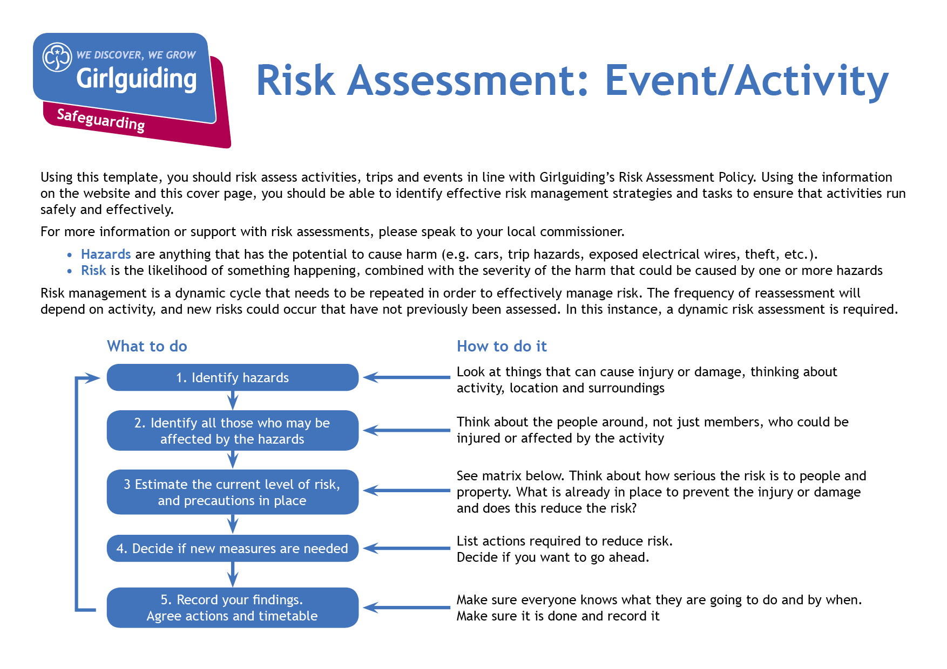
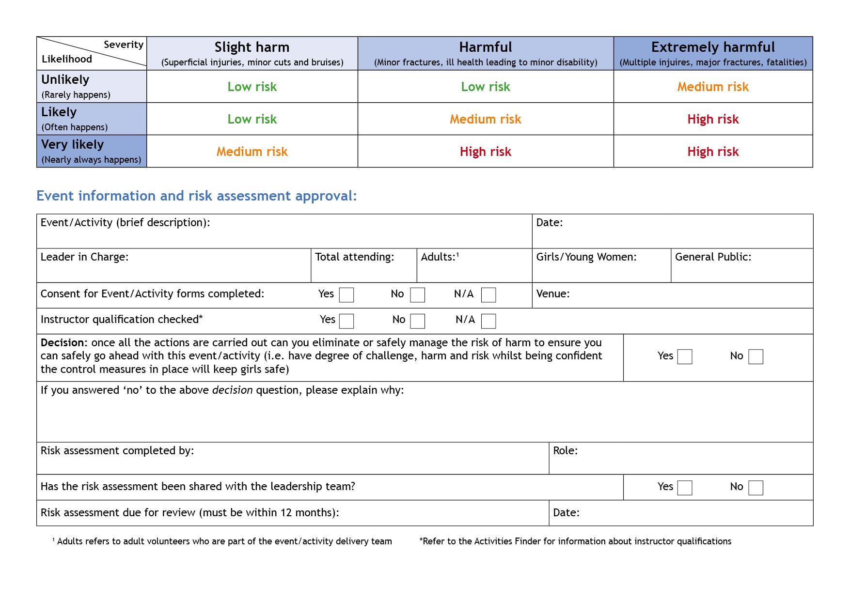

Hazards  What could cause harm or damage? | Who or what is at risk of being affected and how? | What are you already doing?  How have you reduced the risk already? | Likelihood of risk occurring  (L/M/H) | Severity of risk  (L/M/H) | Are further controls necessary?  What else needs to happen to reduce the risk to an acceptable level? | Action by:  name/date

Hazards  What could cause harm or damage? | Who or what is at risk of being affected and how? | What are you already doing?  How have you reduced the risk already? | Likelihood of risk occurring  (L/M/H) | Severity of risk  (L/M/H) | Are further controls necessary?  What else needs to happen to reduce the risk to an acceptable level? | Action by:  name/date

